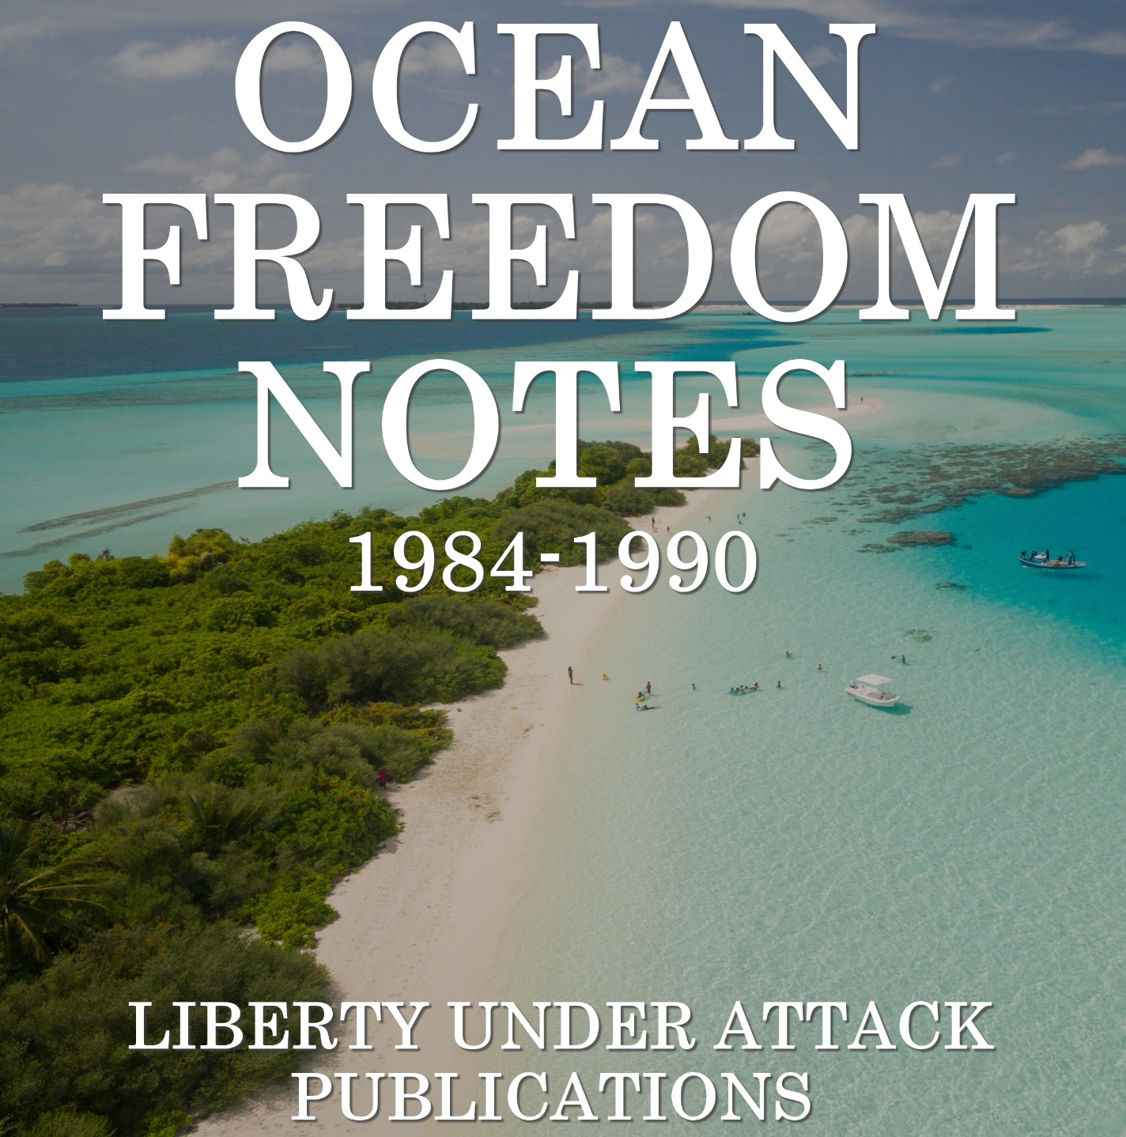

Digitized by Liberty Under Attack Publications. Visit the website, libertyunderattack.com, for more great content like this or to support our efforts.

TRANSCRIBER’S FOREWORD

When I first read Vonu: The Search for Personal Freedom, Rayo introduced a possibility for personal freedom (or, invulnerability to coercion) that I had never even considered—that is, the open ocean. Since then, I have built quite a reputation in my circles for my affinity for the open ocean. I was even asked to join (and did) The Marinea Project, whose goal is to start a village at sea near the Cay Sal Bank.
It’s a dream, something incredible to think about, but finding freedom on the open ocean is more possible than most realize—individuals and families have been doing it extensively for years.
What you are about to read, Ocean Freedom Notes, is a publication that spanned from 1984-1990, and highlights such individuals who decided to “take the dive” and live unconventional lifestyles. In this publication, the contributors discuss inhabiting previously uninhabited ocean islands, starting permanent floating voluntary societies, starting new countries on icebergs, ocean energy sources, and more importantly, firsthand experience from “doers”, not simply theorizers.
And, if you didn’t already, you will also begin to understand some individuals’ endless striving for personal freedom, and the great lengths they went to obtain it. These are the people Rayo would call “freedom pioneers” and he was right.
Thankfully for us in the 21st century, these individuals paved the way so that we don’t have to face the same trials and tribulations that they did. In regards to the political aspect, there’s still much to learn there, but if someone truly desires freedom, they will take the steps necessary.
It is my hope that the reading ahead isn’t just purely for entertainment; rather, it is my hope that these articles will inspire you to go against the grain and try something new, whether it’s in pursuance of personal freedom, or just to expand your experiences as a human being.
To conclude, I think Rayo put it best: “If your State of anchorage becomes intolerable, don’t waste energy in extended public criticism or conflict; apply your free market principles by setting sail for sunnier waters.”

Shane Radliff
September 2017
Liberty Under Attack & The Vonu Podcast

OCEAN FREEDOM NOTES, NUMBER 1
FEB. 1984

INTRODUCTION
Since the demise of OCEAN FREEDOM/OCEAN LIVING, there seems to be no publication covering the self liberation strategy of ocean freedom (also known as sea mobility). I’ve considered publishing such a newsletter myself, but that doesn’t appear feasible. So instead, I’m going to include that kind of material her in LF under this OCEAN FREEDOM NOTES logo. OFN will run to 1 or 2 pages only in any one issue of LF & may not appear in every issue. It will consist mostly of short items, reviews, & access tips to sources of information & equipment relevant to self liberation using ocean opportunities.

THE COMPLETE LIVE-ABOARD BOOK
CoEVOLUTION QRTLY recommends this book (CQ37, p. 113) & says it thoroughly replaces “Living Aboard” which was reviewed in NEXT WHOLE EARTH CATALOG. At $39.95, this is an expensive book, but anyone really considering buying a boat to live-aboard cdn’t [couldn’t] afford not to buy the best advice available before he invests. In that light, this wd [would] be money well spent.
THE COMPLETE LIVE-ABOARD BOOK, by Katy Burke, N.A. 384 pages, 1982, $39.95 postpaid, from Seven Seas Press, 524 Thames St, Newport, RI 02840.

BOOKS ABOUT BOATS
Here are 2 publishers of books about boats, ocean voyages, living-aboard, etc. Write to them for catalogs:
1. Seven Seas Press, 524 Thames St., Newport, RI 02840.
2. International Marine Publishing Co, 21 Elm St, Camden, ME 04843.

BOAT FOR SALE
I came here to Calif. from Lake Erie on an 18 foot sloop, then sold it & built a 25 foot sailboat. But I’ve never used it & now probably never will. I would like to find someone to buy it or trade me something for it. I have a description sheet I can send to anyone who writes for it. The boat is deep-sea, live-aboard, easily-handled, unsinkable, shallow keels, safe. Paul Doerr, 225 E. Utah, Fairfield, CA 94533.

UNINHABITED & DESERTED ISLANDS (book)
This is the only book in print (as far as we know) devoted exclusively to uninhabited islands, over 180 of them, in the South Atlantic, Pacific, Indian, & Antarctic Oceans. Contains hard-to-find information collected from dozens of sources. Detailed descriptions of each island cover physical conditions, political status, history, climate, plant & animal life, etc. Includes 41 maps, list of references, & index of uninhabited islands.
UNINHABITED & DESERTED ISLANDS, 5 ½ x 8 ½, 116 pages, only $9.95 postpaid. (See address below.)

WATER POWER – Summer 1969 issue of INNOVATOR about ocean freedom.
I have reprinted this additional issue of INNOVATOR, & I offer it for $1.00 postpaid.
Contents:
- Go like water, on the water (explains the strategy: “inexpensive mobility made possible by sail, along with no-mans-land status of ocean, gives aqua-libertarian freedom to live in peace as pleases him.”)
- Your boat: passport to freedom (types of boats, recommends trimaran, learning to sail, list of books)
- Houseboats: the easy way out
- Wave motion provides barge motive power
- An ocean lab for ocean living
- Libertarian technology of ecology
- Men of the future (about Richard King, and Roy Bates, Prince of Sealand)
- Gypsies of the Sulu Sea
- Honey: The ideal survival food
INNOVATOR, Summer 69 (order #SU69), 8 pages, 8 ½ x 11, only $1.00 postpaid.
Also still available:
INNOVATOR, Autumn 69 (order #A69), 10 pages, 8 ½ x 11, only $1.25 postpaid.
To get these INNOVATORS, or the book U&DI send payment in cash, check, or money order, US funds only, overseas postage extra, to Jim Stumm, Box 29, Hiler Branch, Buffalo, NY 14223.

MAPS OF ISLANDS
There are 2 US Govt agencies that sell very fine maps of many ocean islands. They are: Defense Mapping Agency, and National Ocean Survey. For more information write to:
1. DMA, Office of Distribution Services, Washington, DC 20315.
2. US Dept of Commerce, NOAA/NOS – C44, Riverdale, MD 20737.
The latest price I have for a DMA map is $8.30 each. They are various sizes up to about 3 feet by 4 feet for one sheet. Very detailed.
As an example of what these maps look like, here, reduced quite a bit, is a map of Palmyra taken from a NOS map. Palmyra is an uninhabited tropical atoll that lies about 1000 miles south of Hawaii near the equator. The book UNINHABITED & DESERTED ISLANDS has detailed information about Palmyra.
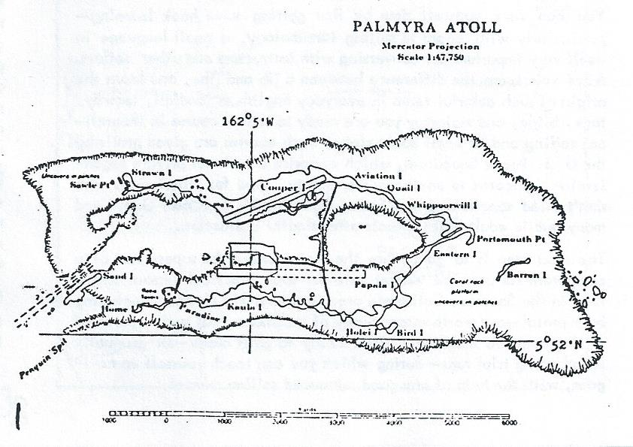

(Editor’s Note: Here are parts 1 & 2 of a 6-part series by Kerry Thornley that was published in INNOVATOR from July to Dec 1966. In upcoming issues of LF/OFN I’ll reprint the remaining parts 3 to 6. The idea of the PERMANENT FLOATING VOLUNTARY SOCEITY was explained by Rayo in these words: “As more libertarians take to the water, some will doubtless anchor & migrate more or less together as a semi-permanent water-borne ‘community’ saving time & money thru exchange of services – ‘internal’ free trade not subject to the scrutiny of any State.” (from VONU: THE SEARCH FOR PERSONAL FREEDOM, page 50. Thornley’s series is somewhat outdated, especially the prices! But it’s worth a 2nd look & makes a good starting point for further research.)

THE PERMANENT FLOATING VOLUNTARY SOCIETY – I
“What’s the use of being a shipmaster if you can’t tell people to go Hell?” – Old Captain’s Proverb
The greater portion of this planet’s surface is out of the effective control of any State, and yet libertarians complain that for the man who would be free there is “no place to go.” This article is the first of a series dedicated to an exploration of the “ocean interstice” as a means to personal liberty and economic freedom.

SMALL BOATS
For as low as the price of a late-model car an individual can purchase a sea-worthy vessel large enough for a small family. This writer is acquainted with a couple who bought a used 26-feet yacht for somewhere around $500 and lived aboard, with their small daughter, sailing the Pacific for a year. Since these folks were not averse to a steady diet of fresh sea food, expenses were quite low – for, as the man of the family pointed out, “There was no place to spent money out there.” (And on a previous voyage to the Virgin Islands they had stocked up on rum at $1.25 a gallon.)
For the less adventurous a slightly larger investment will fill the galley with dry-land staples. And for those who want to get grim about investing money on a boat, it is no problem to spend over $30,000 for a fancy yacht. But suitable used – or brand new – boats can be had for much less.
You can save yourself time by first getting some book learning – particularly with regard to sailing terminology, a small language in itself very important for conversing with instructors and other sailors. After you learn the difference between a jib and jibe, and learn the origin of such colorful terms in everyday English as landfall, leeway, tack, bilge, and mainstay you are ready to take a course in theoretical sailing and/or small boat safety. Such courses are given gratis by the U.S. Power Squadrons, which comprise a national private organization dedicated to on-the-water safety. And for libertarians who don’t mind sanctioning the State, both the U.S. Coast Guard and many public adult night schools offer similar instruction.
The next step is to go out on the water under the supervision of a competent sailor. The market rate for such practical lessons at this time in Southern California is around $10 an hour – including boat rental – and worth every penny of it. Six hours of such supervised sailing ought to make you about ready to go it alone – for gradually lengthening trial runs – during which you can teach yourself to navigate, with the help of any good advanced sailing manual.
By this time, if you have not been doing so before, you will probably be keeping an eye out for that special boat that fits YOU. A sailing vessel with a motor of some kind is probably the best bet for exploring the ocean “interstice” on a small scale – combining fuel economy with flexibility. There are boats made of steel, fiberglass, and wood. Some are built for speed and others for cruising. You will be learning more about the choice of a boat for yourself in the process of becoming sea-worthy; meanwhile, the steps outlined above will help you “get your rudder wet.” KERRY THORNLEY

THE PERMANENT FLOATING VOLUNTARY SOCIETY – II
“I glance at the chronometer...I stare at the thin red lines...if only the shore world were regulated by a force as logical—as honest—as the Law of Storms.” STERLING HAYDEN (1)

LARGE BOATS
A former political activist who decided to eliminate the middle-man in his crusade for individual freedom, Bill Beer illustrates in the flesh the Permanent Floating Voluntary Society concept. The Beers-Bill, his wife, Sue, and their 3 ½ year-old daughter, Barrie—perform the combination host-crew-guide services of the new family occupation, charter sailing, aboard the TRUE LOVE (which starred as a major prop in the movie, “High Society”) about half their days on the Caribbean. When they are not chartering or sailing on a busman’s holiday, their boat is tied to the dock in Charlotte Amalie of the U.S. Virgin Islands. Here the Beers make repairs and mingle with the 20 or so other couples in the Virgin Island charter fleet.
The Beers acquired the capital necessary for setting up their new business by selling all their property “down to the TV set.” Then they traveled to Connecticut where they purchased the TRUE LOVE.
At this time Sue Beer had no sailing experience and Bill had never owned a boat. They learned seamanship the hard way – under the tutorage of a dense fog, a churning inlet, a sandbar, 200 miles of inlet waterway, and a storm in the Atlantic, in that order, on the trip down to the Caribbean – which prepared them for successful sail navigation of the reef-strewn, poorly-charted Bahamas archipelago when their motor blew up near the end of the voyage.
But now Bill can say, “We have a freedom and an independence matched by few and the solid security of near self-sufficiency. We could ask no more.” (2)
Charter sailing tourists in colorful parts of the world, as the Beers are doing, is a good way to make money while living at sea, but it is not the only way in which a large boat can serve as a tool of production. Simple freedom from police harassment for group activities – such as wild parties, clandestine political meetings, illegal medical operations – is a valuable condition which a boat captain can provide for a fee. In addition, he can run cargoes to out-of-the-way places unserviced by major shippers, provide transportation to escaping political refugees, and undertake speculative anti-State ventures – such as the smuggling of American cigarettes into Spain, where high tariffs make such operations, however dangerous, extremely profitable. Smuggling opportunities in a world of antilibertarian trade policies, in fact, are legion – one can take diamonds out of Africa and South America, run arms to rebels in Cuba, land used auto and refrigerator parts in Mexico, bring gold into certain near-totalitarian countries where ownership of some is unlawful...all for life, liberty, and property.
Large boats, in short, offer a way to liberty for those interested in economic as well as personal freedom but who yet do no possess capital necessary for such Permanent Floating Voluntary ventures as shipping lines or man-made islands, to be discussed in the future articles of this series. KERRY THORNLEY
(1) WANDERER by Sterling Hayden (Knopf, 1963)
(2) “A New Life at Sea For Family” by Bill Beer in the Santa Monica EVENING OUTLOOK (WEST Magazine Section) of 16 July, 1966.

OCEAN FREEDOM NOTES, NUMBER 2
May 1984

SSCA COMMODORES’ BULLETIN
The SEVEN SEAS CRUISING ASSOCIATION BULLETIN is a monthly newsletter written by & for people who live aboard small, seagoing sailboats. SSCA has been in existence in 1952. To become a full member (commodore) your only home must be a seagoing sailboat, you must have lived aboard it for at least a year, & you must be recommended by 2 SSCA members. But anyone may subscribe to the BULLETIN. The SSCA BULLETIN consists mostly of letters from “commodores” in which they describe their cruising experiences, often giving very definite info about the passages, ports of call, harbor conditions & facilities, reefs & currents, customs officials, where to find bargains & reliable services, etc. This is hands-on, no BS, hard info.
SSCA proves that this seagoing life is do-able, because these folks have been doing it – for 32 years. Almost every letter mentions the size (length) of the writer’s boat & I notice that most are over 35 feet, though a few are smaller, down to 25 feet. And I get the impression that the vast majority of SSCA members sail as man/woman couples, though there are a few singles. So we can learn from the experts, those who are doing it, what is the best way to go in this lifestyle, i.e. as a couple, in a boat 35 feet or larger.
The BULLETIN runs about 30 pages per monthly issue, 5 ½ x 8 ½, $18 per year. Back issues & index are available. Write: SSCA, POB 2190, Covington, LA 70434. Recommended.

LETTER FROM DAVID H.
The best national boating magazine I read is CRUISING WORLD (524 Thames St, Newport, RI 02840). I feel it has the most personal orientation. Also, they have a resource list of people to contact if you want an opinion about a particular boat, people who have owned it or do own it, & are willing to share opinions about it.
And the best regional – most person-to-person orientation – periodical I know of is LATITUDE-38, out of Sausalito, Calif. I say regional as it’s mostly for Bay Area folks, but many people in different states, & world cruisers, subscribe. It would still be a good resource for someone living in another part of the country.

CoEVOLUTION QUARTERLY, OCEANS ISSUE (#23, Fall 79)
This issue contains a 100 page section devoted to oceans & boats, by the WHOLE EARTH CATALOG people, with their usual flair and thoroughness. It includes “The Whole Sea Catalog” (access to books & tools), “Ocean Power: A Salt Solution” (5 ways to get energy from oceans), & “Ocean Arks” by John Todd (of New Alchemy Institute), which describes Todd’s vision of a greenhouse on a sailboat, almost a blueprint for a vessel in which one could live a self-reliant life on the ocean. Besides this oceans section, CQ 23 also contains all the usual CQ features, including soft technology, land use, nomadics, etc. to fill up 144 pages.
You can order CQ 23 for $3.50 from Box 428, Sausalito, CA 94966.

FREE COMMUNITY ON ICE
Proposal Summary: Create new “land” for a libertarian new country by towing a tabular iceberg from Antarctica & grounding it on an unclaimed reef in an area about 1200 miles south of Tahiti. The iceberg would provide living space & fresh water. An OTEC would provide electricity using the iceberg for the cold side of the process. This would power a methanol synthesis plant. Fresh water, methanol, & other industrial chemicals would be exported in oil tankers to distant markets. Additional icebergs would be brought from Antarctica to replace bergs that melt & are consumed.
New country projects face a political/economic dilemma. Such new countries are usually thought of as trading centers, & for economic viability as a trading center such a community must be situated near a populated area. But this puts it right under the eye of a powerful govt that won’t let it remain free for long, if it can even get established. To remain free, a minimum requirement is that a new country must be located far away from any area of immediate interest to existing govts, but that means it won’t be viable as a trading center. So how then can it be made economically viable? I suggest: the community could make & export bulk commodities for which a large & growing market exists. Once this economic foundation is laid, it might evolve, years later, into a trading center.
A place where this might be done is on one of the submerged Pacific Ocean reefs that lie over 1000 miles south of Tahiti, in the 30’s of south latitude. This is in the same subtropical latitude (though not at all near) northern New Zealand & New South Wales, Australia, so the climate would be similar to those places. The many suitable reefs in this region include Wachusett Reef, Ernest Legouve Reef, Maria Theresa Reef, & others not named on many maps. None of these reefs are claimed by any recognized govt.
A look at distances will show how isolated this region is: Ernest Legouve Reef (to take one example) is about 650 miles SW of the nearest inhabited island which is Rapa in the French-owned Austral Islands. This reef is about 1150 miles S of Tahiti. New Zealand lies about 1670 miles to the west of it. And due east there is nothing but water for over 4500 miles until you reach S. America. The ocean to the S is also completely empty (except for icebergs) for over 3000 miles until you get to Antarctica.
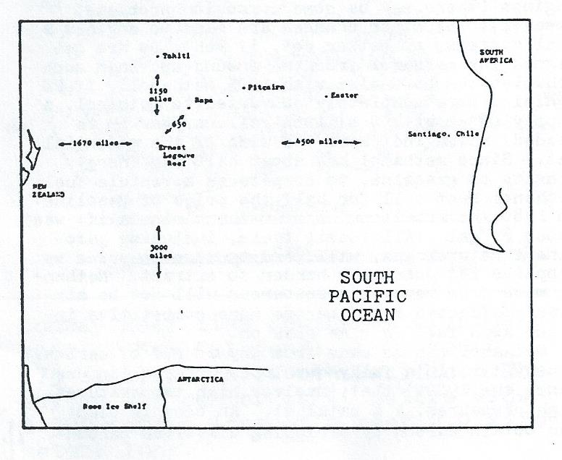
Visual representation of distances described above
These distances mean that a free community here would be outside the immediate area of interest of any govt & would have as much safety from govt coercion as distance can provide anywhere on Earth. Secondly, these huge distances indicate that there is a vast empty region in the SE Pacific that would provide almost unlimited room for expansion for a successful new country if a means of living on, under, or over the ocean could be developed.
To provide for living space this reef could be built up using conventional landfill or oil platform technology, but that would provide only a very small amount of expensive space. A cheaper way to get a large amount of acreage is to tow a tabular iceberg from the Antarctic Ocean & run it around on the reef to anchor it in place. Antarctic icebergs are rectangular blocks, flat on top, over 1000 feet thick, with about 200 feet of that standing about the water line. The largest iceberg ever seen was about 12,000 square miles in area, so the size limitation lies not in what’s available, but rather in the ability to tow such massive bodies.
The iceberg would provide fresh water for the use of residents & also for export. (Icebergs are fresh water ice, not frozen seawater.) Of course, the ice would melt in the warm lower latitude, but perhaps an insulating covering could be applied to it to retard melting. In any case, it would probably take a large berg several years to melt. And as one berg melts, another would be towed up from the Antarctic to replace it, & then another to replace that one, & so on. As the ice melts, the water would be pumped into former oil tankers to be shipped to populated regions where water is scarce, such as to Australia, & southern California. That would be one export.
Energy for such a remote ocean site could be provided by harnessing wind or waves, but the most promising source would be to harness the temperature difference of hot & cold water in an OTEC (ocean thermal energy conversion system). Warm water could be taken from the surface of the ocean, which acts like a huge natural solar collector. The cold side of the system would be the iceberg. The energy generated by this OTEC could be used to synthesize methanol, which would be another primary export.
Over one billion gallons per year of methanol (also known as wood alcohol) is now made in the US from natural gas in synthesis plants along the Gulf coast. It is used as a solvent & as a feedstock in other chemical processes. Methanol can be used for fuel, both for stationary plants & for vehicles. Blended up to 15% with gasoline, it can be burned in existing internal combustion engines (there may be some corrosion problems, however). If minor changes are made to engines & fuel systems, or better yet, if vehicles are designed for methanol from the ground up, then such vehicles can be fueled with 100% methanol. If US vehicles were completely converted to methanol, a supply of about 200 billion gallons/year would be needed, which indicates the size of the potential market. Since methanol has about half the energy density of gasoline, to compete as a vehicle fuel, methanol must sell for half the price of gasoline. In 1980 the retail price for methanol in Calif. was about $1/gal. All fossil fuels, including gasoline & natural gas, will tend to rise in price as supplies get scarcer & harder to extract. Methanol made from renewable resources will not be similarly affected & should become more competitive in price as a fuel as time goes on.
Methanol can be made from any source of carbon, plus water, in a fully developed process (in use since the 1920s) that involves high temperatures, high pressures, & a catalyst. An oceanic plant can obtain carbon by stripping dissolved carbon dioxide from sea water, which is a highly efficient process. Methanol is a liquid at room temperature, with a high energy density, so it could easily be transported long distances to market in existing oil tankers. The hazards of pollution from spill should be less with methanol than with oil because methanol is completely soluble in water.
High technology machinery, such as an OTEC or a methanol synthesis plant, for any remote site with access to the ocean could be assembled on barges in low cost Asian shipyards, perhaps in Japan, Korea, or China, & towed to its final destination. Depending on the market, other products could be produced in oceanic chemical plants, rather than, or in addition to, methanol. One such possibility is ammonia made from hydrogen (from water) & nitrogen (from air). Ammonia is also a liquid that can be transported in tankers & it’s used extensively as a fertilizer. Ammonia now is made from fossil fuels & consequently has been rising rapidly in price. Other possible products include any industrial chemicals that can be extracted or synthesized from seawater & the atmosphere & delivered to distant markets at competitive prices.
Thus, a chemical industry appears to offer a sound economic base for a libertarian new country at a remote ocean site which would probably not be viable in its early years as a trading center.
References:
1. “An Offshore Energy Industry” by Jim Stumm, THE CONNECTION 87, p. 13.
2. “Icebergs” by Jim Stumm, THE CONNECTION 109, p. 107.
3. LAST FRONTIERS ON EARTH by Jon Fisher, chapter 3, p. 29.
4. “The Case for Floating Islands” by Gary Hudson, cassette tape of speech at FREELAND I conference.

MACHIAS SEAL ISLAND
This is an island of “undetermined sovereignty” off the coast of Maine, claimed by both Canada & US. A letter to the chamber of commerce in a nearby town in Maine asking for info about Machias Seal Island resulted in this reply:
“I have been taking people to Machias Seal Island since 1940. I guess that is why your letter was sent to me. Machias Seal Island is not owned by a private party. There is a Canadian lighthouse that is manned, plus a Canadian warden from June-Sept. The island is 1850 feet long & 937 feet wide at the widest part. Both US & Canada claim it, US by the Treaty of Paris & the Treaty of Ghent. Canadian merchants built a light on it in 1832. Canadian Govt later took over the light.
“In 1865 Canada tried to claim the area & started armed conflict by boarding the ‘Essex,’ captained by Barna Beal. The Canadians were thrown overboard & thrown back aboard their vessel completely beaten & driven from the area. Barna ruled the area for many years. He was a great friend of the Canadian light keepers.
“Machias Seal Island is 10 miles from US mainland, & 11 miles from a Canadian island. It is under the US coast, you travel south, & west of the Canadian island. The island was named Machias because it is off Machias Bay & near the town of Machias Maine. I take people out there & do not go thru customs.” Barna Norton, Jonesport, ME 04649

THE PERMANENT FLOATING VOLUNTARY SOCIETY – III
“The term ‘cheap flags’ refers to the three States, Panama, Liberia, and Honduras, which lend their flag indiscriminately to all ships provided the owners pay once a registration fee and a very low yearly registration tax. Apart from this the shipowners sailing under the ‘cheap flag’ are not subject to taxation...Furthermore, this freedom from taxes is guaranteed by the law at the same low level in Liberia for 20 and in Honduras for 30 years. It is most interesting that thus three small and underdeveloped States achieved foremost positions in the world shipping market in spite of the various obstructionist efforts by others, States and competitors...” –PEACE PLANS (1)

SHIPS AND SHIPPING
During the last century no voice was louder in calling for government intervention than that of the American shipping industry. Not only did the shippers want subsidies (in order to better compete with the subsidized lines of England), but they were quite willing to tolerate – and sometimes even encourage – trade tariffs as a means of enticing Congress to grant them privileged status. They got their intervention. Now American shipping is on an overall decline – and shippers are demanding increased subsidies (in order to better compete with the nonsubsidized “cheap flag” lines)! If it has seriously occurred to any American shipowner that the industry’s trouble is due to the “expensive flag” of tariffs, make-work legal regulations and, yes, subsidies (for other people) and the resulting taxation – he is probably no long owner of an American (registration-wise) ship. For the most cheerful thing an American shipper can hope for besides a handout, these days, is a good and bloody full-scale war.
Keeping this in mind along with the corollary that anyone in close sympathy with the policies of American shippers cannot be expected to have much understanding of economics, the interested libertarian will find THE PRINCIPLES OF OCEAN TRANSPORTATION by James Vernon Metcalfe (a Professor of Foreign Trade at Seattle University) a very fine book. Chief among its virtues is its comprehensive yet relatively concise approach to a field that is usually written about in either a highly specialized manner or in a style so popular as to be superficial. THE PRINCIPLES OF OCEAN TRANSPORTATION is the introductory book for the libertarian interested in taking advantage of the Freedom of the High Seas on a heavy-industry level. It provides orientation in all aspects of operating merchant vessels.
The chapter titles are: Ship Characteristics; Ship and Cargo Measurements; Before the Vessel Arrives; Entering a Vessel From a Foreign Port; Terminal Operation; Vessel in Port; Cargo Handling; Cargo Procurement; Cargo Stowage; Vessel Stability; Cargo Documentation; Ocean Freight Rates; Vessel at Sea; Vessel Chartering; Foreign Freight Forwarders; Marine Insurance; Admiralty and Maritime Law; Labor Relations; Ocean Shipping via Canals; World Fleets and Ports; Domestic Commerce of the United States; The United States Merchant Marine; and Reports from the Lookouts. This book can be purchased from the publishers, Simmons-Boardman Books (30 Church St., New York 10007, 1959), for $5.50.
The prime consideration with regard to merchant shipping is capital. Unless you have or can raise several hundred thousand dollars, starting a shipping line is out of the question. (2) Possibly a number of libertarian businessmen will form a company for precisely this reason – for no industry is less physically subject to State harassment, and therefore any better prospect for long-term investment, than ocean transportation.
Another possibility is for associations of libertarians to form, each for the purpose of buying one ship, and for these associations to cooperate under a single company trade mark. Each association could represent a particular faction within the movement. Thus one might envision a ship with a limited constitutional government all of its own sailing beside one without any government at all. And perhaps there would be an aircraft carrier called the HENRY GEORGE upon which the captain collected “deck rents,” while the sailors aboard the schooner GREEN REVOLUTION experimented with farming at sea. The possibilities for cooperation and diversity are at least intriguing. And the Kerista people will be pleased to know that ships under at least two present-day flags have both male and female crew members.
Finally, should the day ever come that Agoric Shipping Lines (or whatever) would decide to be done altogether with the political powers of the world, many existing merchant ships (including all those built with U.S. subsidy money) are specially made for quick conversion to fighting status, so it would not be the usual matter of armed government goons saying to unarmed businessmen, “Come let us reason together.” KERRY THORNLEY
(1) PEACE PLANS (J. M. Zube, Wilshire St., Berrima, N. S. W., Australia), issue no. 7, page 25. This quote translated by Zube from a review in HEFT (a German publication) by Solneman. It appears in full as part of a two-and-a-half page proposal in PEACE PLANS entitled “Freedom of the High Seas to be Extended to Continents,” an excellent article in its own right.
(2) Now and again one hears of “war surplus liberty ships” or something of that order for sale at less than a hundred-thousand dollars. By the time such vessels were put into sailing order, I have it on good authority, a fantastic monetary outlay would be needed. I have not priced ships extensively but do know of one medium-sized tanker in bad condition that was valued at $400,000. Of new ships, those made in Japan are said to be among the most reasonable and those built in the United State are exorbitant at no appreciable increase in quality.

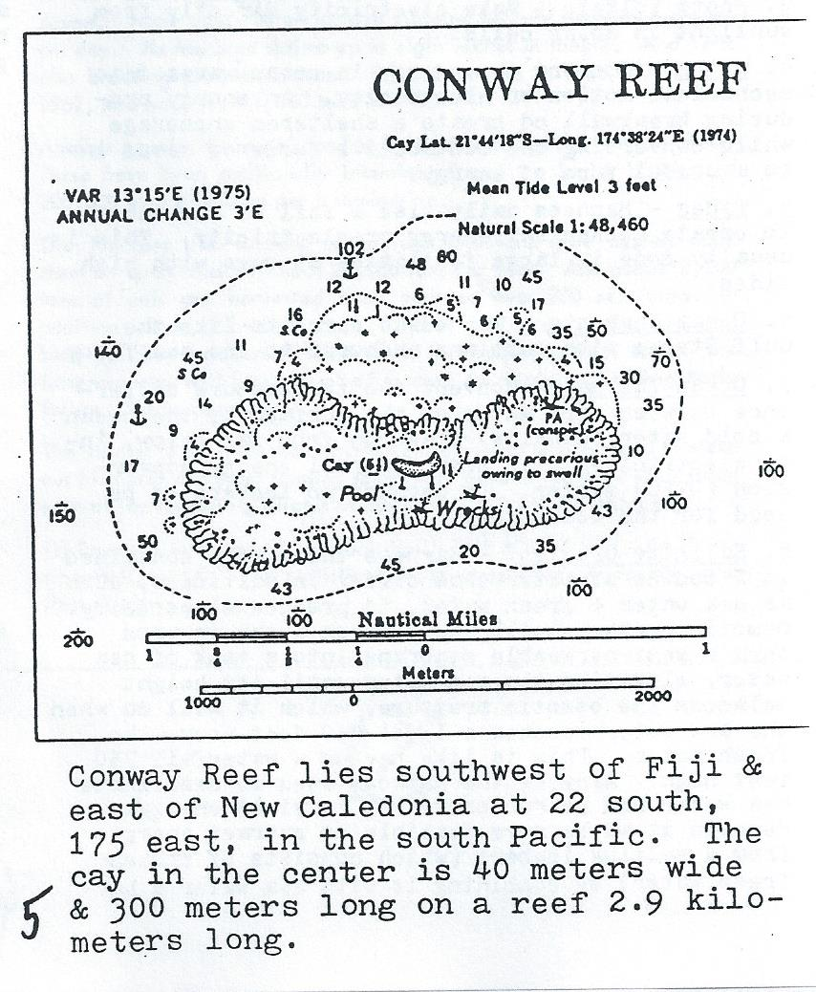
OCEAN FREEDOM NOTES, NUMBER 3
Oct. 1984

EDUCATION AT SEA
Sharon Lisa Prytherch, who is 14 years old, has never been to school in her life. Nevertheless, she has just passed the 1st part of the London University Entrance Examination, according to a letter in SSCA BULLETIN, May 84. Sharon lives with her parents aboard the ketch “Dalisha,” now (early 84) wintering in Cartegena, Spain. Her parents taught her the basics, then she received further lessons via correspondence courses.
Meanwhile, across the world, Paul & Hillary Stoeken are studying 1st & 3rd grade lessons from Calvert School, Home Instruction Dept., Tuscany Rd, Baltimore, MD 21210, while sailing with their parents on the ketch “Independence,” recently cruising in French Polynesia.

OCEAN ENERGY SOURCES
1. Wind – Use a wind energy conversion system (windmill) to make electricity from wind, or for water pumping or other direct us of mechanical motion, or to compress air or pressurize hydraulic fluid to transmit mechanical motion some distance away.
2. Solar, Thermal – Use heat from the sun for water heating, space heating, to desalinate seawater, etc.
3. Photo Voltaic – Make electricity directly from sunlight in solar cells.
4. Waves – Convert the energy in ocean waves into mechanical motion or electricity. An energy producing breakwall could create a sheltered anchorage while converting the destructive force of waves into a useful form of energy.
5. Tides – Harness daily rise & fall of the tides to create mechanical energy or electricity. This is usually done in large facilities at bays with high tides.
6. Ocean Currents – Tap ocean currents like the Gulf Stream with turbines anchored to the sea floor.
7. Ocean Thermal – Convert the temperature difference between warm water on the surface of the ocean & cold water (usually) drawn up from far below, into electricity in an ocean thermal energy conversion (OTEC) system. Or perhaps an iceberg could be used for the cold side.
8. Salinity Gradient – Harness the energy contained in 2 bodies of water that differ in saltiness, such as sea water & fresh water, to produce electricity. Osmotic pressure will cause fresh water to pass thru a semi-permeable membrane into a tank of sea water, elevating the sea water until its height balances the osmotic pressure, which it will do when the sea water reaches a level 750 feet about the fresh water. This is like having a waterfall 750 feet high. Many of the methods used to desalinate sea water can be run backwards to yield energy. Perhaps it would be more feasible to extract energy from a melting iceberg (which consists of frozen fresh water) by combining it with sea water and harnessing the salinity gradient rather than the thermal gradient.
Reference: “Ocean Power: A Salt Solution” by Gerry Wick, COEVOLUTION QUARTERLY 23, Fall 1979.

THE LONELIEST ATOLL
If you travel toward the southeast across the Pacific, you’ll encounter dozens, if not 100s, of tiny coral atolls. Eventually, you must come to the last one, & this is it, the last, remotest atoll, Ducie. How remote is it? You can travel S, N, or E from Ducie & find nothing but empty ocean for 1000s of miles. To the S, there is only Antarctica. Due N, you’d pass to the E of the Tuamotus & Marquesas, cross the equator, & not hit land until you reach Calif. Heading E., you’d pass N of Easter Island & find no landfall until you reach South America.
Only to the west are there nearby islands, & they’re nothing much. Ducie is one of the 4 islands of the Pitcairn group, all uninhabited except Pitcairn itself. And the population of Pitcairn is only about 60 & falling. Ducie lies about 300 miles east of Pitcairn. The only vessels Pitcairners have are open longboats, not suitable for long ocean passages. Consequently, they never visit Ducie. In fact, Ducie is seldom visited by anyone, & it has never been populated. A couple ship-wrecked sailors have lived there for brief periods, but that’s about it. If you’re looking for a really remote hideout, Ducie would be on your short list of good prospects.

THE PERMANENT FLOATING VOLUNTARY SOCIETY – IV
“In Japan a restaurant has been planned under the ocean where patrons can watch the fish and vice-versa. And perhaps it won’t be long before some enterprising American builds a resort hotel nestled twelve fathoms down on the pure white sand of a reef valley and hemmed in on all sides by tumbling gardens of coral and the constantly changing, multicolored life of the sea.” – THE BOUNTIFUL SEA (1)

MARINE CITIES
Many previous issues of INNOVATOR have contained reports on the “pirate” industries of the North Sea – commercial endeavors which do not pay “protection” money to the governments of Europe, since they are located outside the territorial boundaries of some, as defined by International Law. As the food, mineral, and living space potential of the sea come more under the control of technology, enterprises of this nature increase in number on continental shelf areas all over the world.
Farming the sea, for both fish and edible sea-weed, is emerging from the experimental stage. Some twenty percent of Japan’s coal is mined from beneath the ocean floor, and countless other pilot mining projects – for every mineral imaginable – are under way around the globe. The bottom of the sea is also already a widely recognized storage place. One U.S. city stores its water supply beneath its harbor and fuel has been stored successfully by the U.S. Navy in the Gulf of Mexico. The prospect of sea cities, on and under the surface, is now taken for granted by informed prognosticators – and the prospect is immediate.
There are two ways libertarians can take advantage of these developments:
(1) FOCUS EDUCATIONAL EFFORTS on the men and women who are involved in these projects. Meet and become acquainted with ocean frontiersmen. (Think how handy such friends might be in an economic or political crisis!) Ask them many questions. Find out what their professional problems are and suggest solutions that are in accord with their libertarian principles. Inform them of their rights above the law. Tell them how to foil the statist mentality and defeat the expansionist efforts of the national bureaucracies. (These are things you can do no matter where you live. The marine biology professor at a Midwest College is as much a part of what is virtually a Second Industrial Revolution as the hypothetical “enterprising American” who builds a resort twelve fathoms down. And if you live in an Arizona ghost town you can still write letters, or even newspaper columns.) Demonstrate to the marine pioneer that his prime advantage is the long tradition of Freedom of the High Seas, and that it will be personally profitable to him if he does all that is within his power to maintain it.
(2) CONCENTRATE INVESTMENT OF RESOURCES on maritime metropolis projects, particularly on man-made floating islands and other highly mobile capital, since this can best be defended against future attempts at control or confiscation by the world powers. (Another possibility that should not be entirely ignored though, is the “bubble on the bottom” concept, especially as a means of hiding large quantities of property. Construction costs are often less, and protection from storms is usually superior.) Nor are monetary resources all that can be invested. A student entering the university can direct his studies toward aspects of the oceanic scene, in most cases with little or no shift in his field of interest. The student of law, for example, can specialize in Maritime and International Law. The engineer can focus on marine engineering, etc. Servicing and communications industries will also have a market in marine communities. A private sea-air postal system and a few libertarian-edited marine industrial journals might get things off to a good start.
Future articles in this series will report on specific commercial activities which are now thriving in salt water, many of which are probably on the sites of the free cities of tomorrow’s voluntary world. KERRY THORNLEY.
(1) THE BOUNTIFUL SEA by Seabrook Hull (Prentice-Hall, 1964).

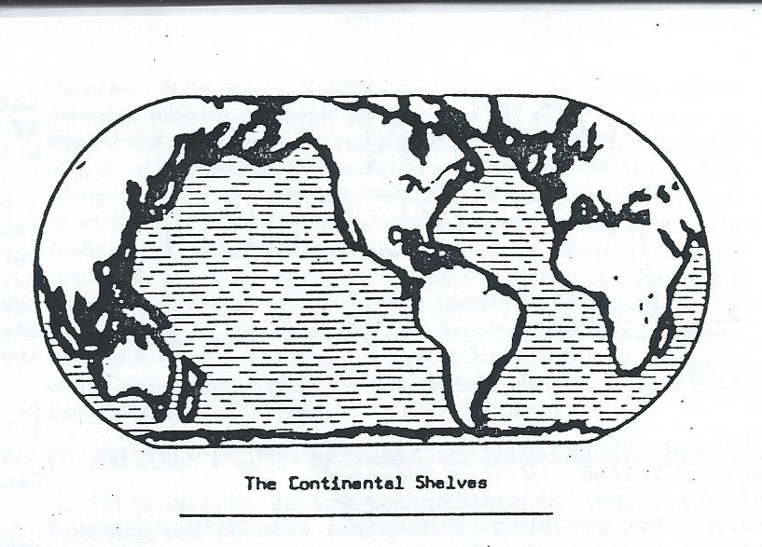
THE PERMANENT FLOATING VOLUNTARY SOCIETY – V
“Control of foodstuffs in the sea has a beginning similar to that of its counterpart of land. Start with the weeds. When the weeds become cultured, we call them plants. Once culture takes hold, then yield accelerates, and we have more than enough for our immediate needs.”
ROBERT M. SNYDER (1)

AQUACULTURE
Japan is the world’s leading nation when it comes to farming the sea. Over twenty kinds of seaplant, for example, are marketed there for eating purposes. Some of these are harvested wild, but many are cultivated from seed, transplanted to oceanic nets, and harvested about two months later. They are then dried on sheets on bamboo mats. This end product, while is usually requires of the Occidental that he develop a taste for it, is rich in vitamins, and very popular with the natives of Japan.
In 1954 a Dr. Matosaku opened the first commercial shrimp farms in Japan. Nine years later he was shipping seventy pounds of shrimp per day. He has bred shrimp up to eight inches in length. And he is also breeding prawns – a total of 2,860 pounds in 1961, 500 tons in 1962, and more than 1,000 tons in 1963.
Another popular Oriental food is a shellfish called the wreath shell. These have been artificially inseminated and a single batch of 200,000 eggs produced per insemination.
The Japanese also suspend racks from floats and grow oysters upon them in quantities of about 20,000 tons per year. And about 2,200 tons of eels are harvested each year on over 750 eel farms. In addition bream, blowfish, bass, halibut, and grey mullet are also bred by “fish ranchers.” And when the market is bad, there are fatteners who will buy part of a fish crop to retain in holding tanks for speculative purposes.
The market is open for the ambitious entrepreneur who is ready to stake out his claim and start farming somewhere beyond the three-mile-long arms of the landgoing pirates of our time. KERRY THORNLEY
(1) From the foreword of Seabrook Hull’s THE BOUNTIFUL SEA (Prentice-Hall, 1964). The statistics on Japanese aquaculture are also from this book.

OCEAN FREEDOM NOTES, NUMBER 4
Mar. 1985

BOOK REVIEW: BLUEPRINT FOR PARADISE, How to live on a tropical island, by Ross Norgrove.
This is essential reading for anyone seriously thinking about moving to a tropical island. Norgrove covers all the details you should consider, such as: How do you select the one island right for you out of many 1000s? What should you look for when buying island property? What should you consider while planning the house you will build? What obstacles will the island govt throw at you? How much will it cost? What about food, water, building materials, repairs, medical care, schools for your kids, jobs, etc.? All this & more is covered here. The author writes from his many years experience as an island-hopping charter boat operator & an island dweller himself.
Norgrove divides all islands into 5 categories:
Category 1 islands are remote, uninhabited, 100s of miles away from any town. A Category 5 island has a town, electricity, hospital, & airstrip. The in-between categories are in-between. In my books I have considered the possibility of living on islands that would fall into his Category 1. Norgrove agrees that living on such island would be difficult but possible, & he discusses the requirements in realistic detail. But his book is mostly about the more civilized islands to which most people are attracted. Excellent job. Recommended.
BLUEPRINT FOR PARADISE, by Ross Norgrove, 1983, 208 pages, 6 x 9, illustrated, soft cover, $14.95 plus $3.00 shipping (order #B120) from International Marine Publishing Co., 21 Elm St., Camden, ME 04843.

HOMAFLOTE, THE LIVEABOARD NEWSLETTER
This is another newsletter for people who live aboard their boat. It says: “Homaflote is an Association of boaters who live aboard, or who dream of it. Our aim is the sharing of useful information gleaned from the experiences of the members to enhance home-aboard living.”
The letters & info in Homaflote seem to be entirely from people who live mostly tied to the dock in various US ports. This contrasts with SSCA BULLETIN which is full of letters from people who are cruising overseas. Membership in Homaflote Assoc. is open to anyone who pays the annual dues of $8.00, which is also the subscription price of the newsletter. SSCA has much stricter membership requirements.
HOMAFLOTE, the newsletter, runs 16 pages/issue, 4/year, 8 ½ x 11, $8.00/year. Back issues available, classified ads at 40¢/word. Write: Homaflote Assoc., POB 1853, Punta Gorda, FL 33950.

TROPICAL FRONTIERS NEWSLETTER
Travelers who want to vacation off the beaten track & visit little-known tropical islands can get up-to-date information from TROPICAL FRONTIERS Newsletter. It provides all the basic facts a visitor needs to know about the islands it covers, as well as news from these exotic places. However, the price is high. The 1st issue runs 9 pages, 8 ½ x 11, & 12 such monthly issues go for $65.00. In this 1st issue there are 2 news items: Tuvalu Councillors resign following charges of nepotism, & Air Polynesia opens N. American office, then a long report on Christmas Island in the mid-Pacific Line Islands, & an article about Private Islands Unltd., a real estate firm that sells islands. The Christmas Island Report covers: people, climate, economy, communications, birdlife, fishing, diving, accommodations, air service, driving, island tours, what to bring, banking/currency, hospitals/health, passports/visas, shopping, church services, & language.
TROPICAL FRONTIERS, about 9 pages per monthly issue, 8 ½ x 11, $65/year, or $15 for 3 month trial. Write: Bill Turner, POB 1316, Eagle Pass, TX 78853.

SEE BELOW FOR IMAGES

THE PERMANENT FLOATING VOLUNTARY SOCEITY – VI
“Undersea mining in some areas is already big business...Magnesium is extracted directly from seawater. Oil and sulfur have been taken from beneath the sea floor for many years. The ocean is already being opened up for commerce, and before long private industry will be spending more on undersea commerce than Government now spends on undersea warfare.” (1)

MARINE MINING
Da Beers Consolidated Mines, Ltd. is engaged in undersea diamond prospecting and mining off the coast of South Africa. Global Marine Exploration Company searches for undersea oil in deep water. Marine Diamond Company, Ltd. (managed by Texan, S. V. Collins) mines by suction for gems. Ocean Science & Engineering, Inc. designs and builds undersea exploration equipment. Richfield Oil Company and Shell Oil Company are building undersea oil fields. Tideweater Oil Company is engaged in undersea diamond mining. And Yawata Iron and Steel Company of Japan mines iron-bearing sand from the ocean floor.
Other companies are playing less direct roles in mineral exploration of the sea. U.S. Rubber has built and tested undersea storage tanks. Dr. Edwin Link, President of the Link Division of General Precision, Inc. has “camped out” in a pressurized tent on the ocean floor, General Dynamics Corporation is one of the many companies that has conducted studies on undersea transportation. Hughes Aircraft has built submarine robot units to assist in the installation of oil wells.
To list all the minerals that are or will be mined from the ocean would simply be an exercise in recitation of the names of most of the elements. A similar exercise would be to attempt a complete list of the companies involved in one manner or another in ocean mining. The important thing to realize is that the heaviest industry is being drawn into this Second Industrial Revolution in the search for minerals. It is therefore essential that libertarians interested in advancing the concept of a Permanent Floating Voluntary Society do some hard thinking with regard to the ever-present problems of property in natural resources.
The First Claim Theory, for example, as some prominent libertarians espouse it (2), would put most future marine mineral exploitation under the control of an aspiring monarchy which calls itself Aqualandia. For his Majesty King Marion I, in a proclamation dated 10 August 1961, published a claim to “all the lands of the world that exist beneath the oceans and other salt water bodies of the world, except that portion of ocean bottom or other salt water bottom lands which are now claimed as the property of the various government in the world, and where such claim is, as of this date recognized as valid by “International Law.” The proclamation goes on to assure that “Aqualandia “does not claim any right to govern, regulate or interfere with the present or future use of the waters above its land,” and adds that Aqualandia’s is patterned after that of England. This proclamation was published in a pamphlet called “The Aqualandian” (The Aqualandia Society, 6812 Santa Monica Blvd., Los Angeles, Calif., 90038) in July of 1966. But somehow I fail to see, speaking only for myself, how recognition of this First Claim (if, indeed, it is the first) would possibly be in my interest.
On the other hand, the standard argument of the most ardent admirers of Henry George, which hold that natural resources should not be claimed by individuals or companies or societies at all, but should be “owned in common” in, at best, a sort of universal profit-sharing plan – and which would tend to condemn the present companies involved in ocean mining for coercively monopolizing the mineral deposits – while certainly more rational than the unmodified First Claim Theory, brings up a host of new problems in its place. And putting aside those which fall into the “who-would-administrate” category entirely, this approach would, unless liberalized, go counter to our primary purpose of winning over to the libertarian position those basic industries now mining the sea.
One factor which may bring about a resolution, at least with regard to the ocean, is the technical difficulties involved. By the time one has extracted minerals of almost any sort from the sea a great deal of thought and energy has been applied. It is far more difficult than driving a claim post into the ground or panning gold. Arbitrary First Claims on behalf of Southern California groups and their like will tend to be ignored, and will be next-to-impossible to enforce. And the Georgists, if they can point out to the mining companies a self-interested motive for voluntarily paying out mineral rent fees to the population at large, will find little opposition from laissez-faire libertarians. In the meantime, it is important that the rest of us develop a rational and simple procedure for establishing ownership of the natural resources in the sea, perhaps along the lines of John Locke’s “mixing labor” formula. KERRY THORNLEY
(1) THE BOUNTIFUL SEA by Seabrook Hull (Prentice-Hall, 1964).
(2) See for example, J. Dohn Lewis, THE LAND QUESTION, and Butler Shaffer, PERSONAL DECLARATION OF PRINCIPLES, in the Jan., 1965, and Sept., 1966 issues of INNOVATOR.
(Editor’s Note: This concludes the 6 part series PERMANENT FLOATING VOLUNTARY SOCIETY which was originally published in INNOVATOR, July to Dec 1966, & reprinted in OCEAN FREEDOM NOTES 1 to 4 in LIVING FREE 24, 25, 27 & 29.)

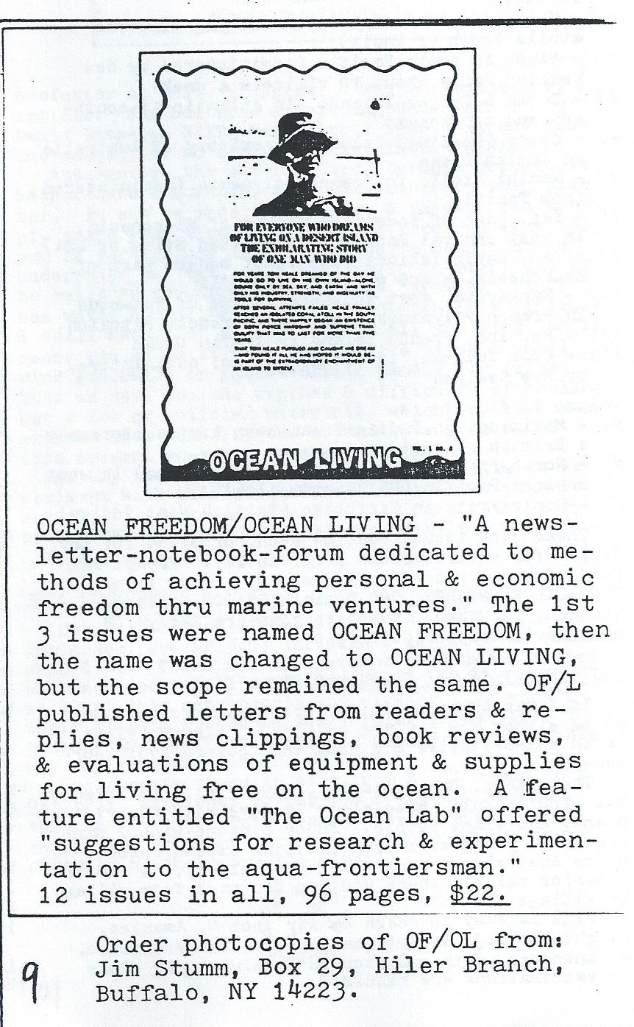

OCEAN FREEDOM NOTES, NUMBER 5
Aug. 1985

TROPICAL FRONTIERS NEWSLETTER, Back Issues
This newsletter was reviewed in LF 29 p. 7, but note new (lower) price & address below. Each issue features one little-known island or island group, with some additional shorter items about other islands. Most back issues are available. These are the islands that are featured in the issues published so far:
Volume 1
#1 – Christmas Island (Kiritimati), in central Pacific
#2 – Tuvalu, in central Pacific (formerly Ellis Islands, part of British colony of Gilbert & Ellis Islands)
#3 – Maldives, in Indian Ocean (string of coral atolls south of India)
#4 – Niue, in south Pacific (administered by New Zealand, only about 10 visitors a week)
#5 – Turks & Caicos Islands, territory of Australia in Indian Oceans
#6 – Cocos (Keeling) Islands, territory of Australia in Indian Ocean.
#7 – Manihi Atoll, in French Polynesia (administered from Tahiti)
#8 – Yap, part of Federated States of Micronesia, in west central Pacific (Associated State of USA)
#9 – Yap, outer islands (the least modern part of Micronesia, where old traditions linger on)
#10 – Mangareva, most southern island of Tuamotus in French Polynesia, nearest to remote Pitcairn.
#11 – Reunion, French island in Indian Ocean
#12 – Cook Islands, in south Pacific, administered by New Zealand

VOLUME 2
#1 – ?
#2 – Maritius, in Indian Ocean near Africa (formerly a British colony)
#3 – Northern Marianas (Saipan, Tinian, etc.) in west central Pacific (US Commonwealth
#4 – Montserrat, in Caribbean (British West Indies)
These back issues cost $4 each, or $7.50 for any 2, $40 for entire volume 1 (#1 to 12). Prompt refunds for any out-of-print issues. Order from: TROPICAL FRONTIERS, 700 Dominik, #1204, College Station, TX 77840. Subscriptions are $48/year, 3 month trial subscription $10.

FIJI, HEART OF THE SOUTH PACIFIC
If I was to emigrate, my preferred destination would be either New Zealand or Fiji. “Finding Fiji” is an authoritative new book that covers Fiji thoroughly.
The author, David Stanley, says: “Fiji is friendly. You’ll fall immediately in love with the vibrant, exuberant people. Enjoy picture-window panoramas as you travel from exciting island resorts where Australians meet Americans halfway, to remote interior valleys where you can backpack from village to village.”
Fiji is easy to reach by air from N. America. Flights to Fiji depart Los Angeles, San Francisco, & Vancouver, with one stop in Honolulu. No visas or vaccinations required.
I also like the way this book is made. It looks like a book that would travel well: good quality paper, tough cover, rounded corners, well designed for slipping into a suitcase or backpack.

SEE BELOW FOR IMAGE
“FINDING FIJI” is available directly from Moon Publications, POB 1696, Chico, CA 95927, for US $6.95.

THE OCEAN LAB by James Parkerson
An Evolution of Solar Stills: The Life Science Library book on WATER says that the maximum output of solar stills having a slanted glass condensing surface over sea water in a basin is 0.13 gallons per square foot per day. Halacy says, in FUN WITH THE SUN (MacMillan 1959), that his still will distill 0.25 gallons per square foot per day (because the wick, unlike the horizontal surface of water in a basin, can always be turned to the sun’s rays, & because the wick breaks up the “crust” of the water, ie the “surface tension”?) An improvement over Halacy’s aluminum foil lining would be gold plated steel, because it is a better reflector of infrared heat rays, & because aluminum is attacked by salt. Gold is an inert “noble” metal not attacked by anything but “aqua regia.”
(Steel foil with pressure-sensitive adhesive backing & gold plating kits were available from J.C. Whitney & Co. in Chicago. Look for it in stores that sell equipment & materials for customizing cars. –JS)
Also needed: 2 (or 4) penlight cells. Another improvement: loops of rope, dyed black, might make better wicks than black toweling, especially if a wave-swing-powered ratchet turns the mounting shaft circulating the ropes thru the sea water in the bottom. Still another improvement: water evaporates much faster in a vacuum than at atmospheric pressure, & a vacuum forms about a 34 foot column of (fresh) water, ie a drinking straw or chemist’s pipette, would lift water only 34 feet, at which point the vacuum becomes complete & the water will rise no farther. The Duke of Tuscany first noticed that vacuum pumps will lift water only 34 feet, which Galileo explained by saying that it is the weight of the air rather than the “pull” of the vacuum. Later Toricelli discovered that atmospheric pressure will support only 30 inches of mercury, thus inventing the mercurial barometer which measures air pressure & altitude. So, if you hoist your airtight still about 34 feet, letting the weight of the water bear on the ocean thru a connecting hose, a vacuum will form above it, accelerating distillation of water & concentration of minerals. A partial vacuum would probably break the glass, even if double high-strength glass reinforced by 2 or 3 bars is used. A partial vacuum is made by leaving an air bubble over the water, strengthening as weight is added rather than appearing suddenly at 34 feet, like a complete vacuum. Also, a vacuum-compression, evaporation-condensation cycle may be necessary, as well as a valve to keep steam pressure from forcing the water out against air pressure. I don’t know how soon I will be able to test these ideas, but I am releasing them now, bare as they are because it is just such tricks that may convert sea-dwellers into super-pioneers.

PLASTER OF PARIS:
Though sea water is almost 3% salt & not quite 1/10% calcium sulfate (plaster of Paris) & just 1/100% calcium carbonate, it is the less soluble calcium salts which precipitate in the first pools of salterns. Salt precipitates in the second pool, leaving more soluble magnesium, potassium, & calcium chloride, etc. in the bitterns. Calcium sulfate, when dehydrated at 215-235°F becomes plaster of Paris, a fine white dry powder which, mixed with 15% of its weight of water, quickly sets to a hard mass of gypsum, used for casts for broken bones, statuary, wall plaster, etc. Its solubility is variously described, but it might be waterproofed with Bitudobe, or a glass or other coating. They are making concrete boats now. I wonder if plaster floats could be made. Highest sulfate content in US water is 1/20% at Lubbock, Texas, more than ample to cause scale in boilers & steam irons.
(Reprinted from OCEAN LIVING, v1n6, page I-34, Fall 1968)

COMMENTS: SOLAR STILLS
These are interesting ideas but there’s an advantage to keeping your mechanism simple & reliable. On a barren island with plenty of room to spare, you could build a solar still of simple design that would cover a large area, & supply all the drinking water from seawater that you could use. Higher efficiency, but more complex stills might be needed on small boats where space was at a premium. Best use of these high efficiency ideas would be in an industrial application where expected future profits might justify extensive R&D to work the bugs out.

COMMENTS: PLASTER OF PARIS:
Since this was written, a better way to make use of these minerals in sea water has been invented. You put some kind of metal mesh, eg chicken wire, into sea water & run a small DC electric current thru it. Minerals from sea water plate out onto the mesh & fill in the spaces to make a solid structure.
This technique was invented by Wolf Hilbertz, a professor at Univ. of Texas, & was the subject of an article: “Why Not Grow A Building Underwater!” by David Lampe in NEXT, March/April 1980. It was also the subject of an article in MOTHER EARTH NEWS.
Apparently, the material made by this process is rather hard & durable, more like concrete than plaster. It can be made in any size & shape. You simply shape your wire mesh into the form you want. So you could perhaps use this technique to construct an underwater habitat, or a boat hull, or maybe use it to build an on-shore structure by “growing” it in sea water & hauling it up on land when it’s finished. A small amount of electricity is all you need, which means you could do it at a remote site using a small wind generator or photo-voltaic panels for juice. This would save you the expense & difficulty of hauling out a lot of building materials, which you could instead extract from abundant sea water. The process would take several weeks or months to complete.
Would any reader who lives near the sea like to experiment with this process & tell us about your results? If you’re interested, I’ll send you a copy of the NEXT article with all the details.

SSCA COMMODORES ROSTER
Dec. 84 issue of SSCA Bulletin (Seven Seas Cruising Assoc., see LF25 p. 6) includes a complete membership list. There are 231 persons or couples listed with home ports all over the world. So there are at least this many people who already live aboard their boats & pursue this sea going lifestyle. I presume only a fraction of the people who live this way happen to be members of SSCA.
Their boats range in size from a 25’ sloop to a 95’ brig, with most in the 30s & 40s. I suspect that many of the boats over 50 feet are used for chartering or other income-earning ventures, besides being their owner’s homes.
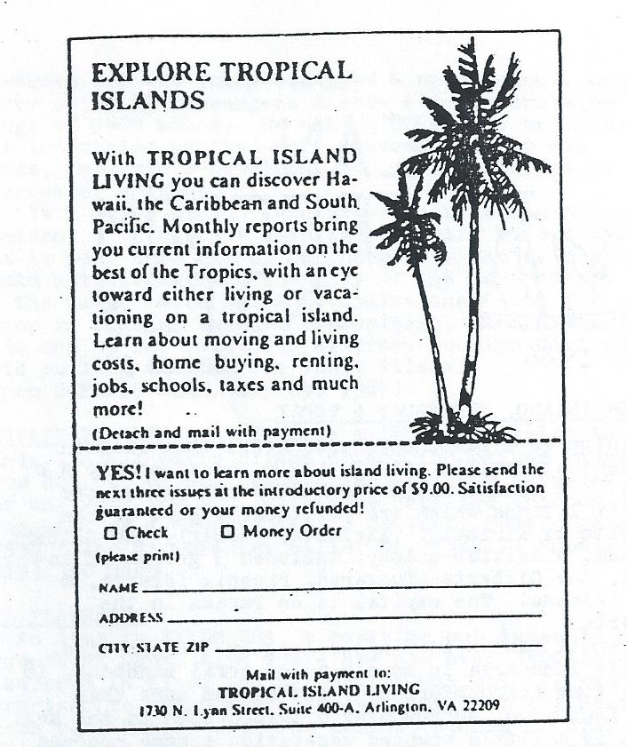
OCEAN FREEDOM NOTES, NUMBER 6
June 1986

CANTON ISLAND, YESTERDAY & TODAY
Canton is a lambchop-shaped atoll that lies in the central Pacific at 3 S, 172 W, considerably N of Samoa. It is the largest & most northerly of the Phoenix Islands which are politically part of the Republic of Kiribati. Kiribati, formerly of the Gilbert Islands, is a British colony, includes 3 groups of islands, the Gilberts (Tungaru), Phoenix Islands, & Line Islands. The capital is on Tarawa in the Gilberts.
Overall Canton is 7 miles long by 3 miles, wide, but the land area is merely a low coral sandbank, 17 miles long (circumference), but seldom more than 1800 feet wide, surrounding a lagoon open to the sea. There is a little stunted vegetation & some coconut palms on the NW side.

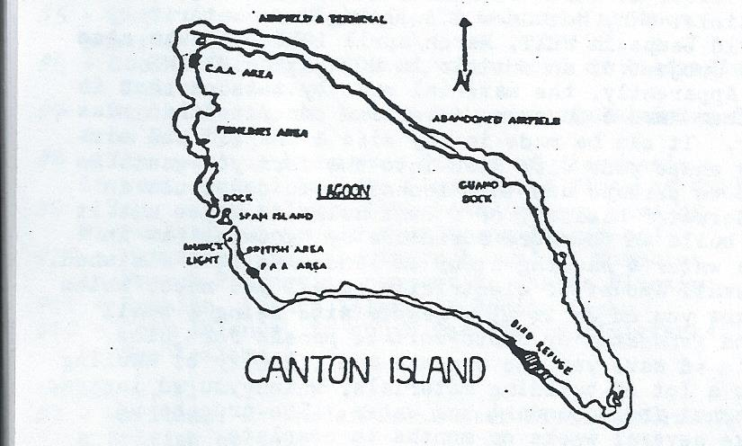

Guano (bird shit) was mined on Canton in the 19th century, but the island never had a native population & was uninhabited most of the time until the 1930s. Then trans-Pacific airlines began to develop obscure mid-Pacific islands like Canton as refueling stops. In 1938 Pan American Airways built a land runway & cleared coral heads in the lagoon to create a seaplane landing area. During WW2 US military forces built the newer airstrip at the NW corner of the atoll. Pan Am & Quantas (Australia) used the island until long-range, non-stop flights became possible. After that the airstrip was maintained for some years longer in case an emergency landing might be needed, but by the 1960s, the airlines had abandoned the island entirely. Canton enjoyed a brief Indian summer when NASA established a satellite tracking station there in 1965, but that was closed down in ’67. During its glory days 100s of people had lived on Canton, only a handful now remain.
Latest word I have on Canton is a letter, dated Oct. 84, published in Jan 85 SSCA BULLETIN from Michel & Jane DeRidder who visited Canton in their yacht “Magic Dragon” (40 foot sloop out of British Columbia). They write:
“Canton...one time trans-Pacific refueling center, then a missile tracking base & communications center, is now a mid-Pacific ghost town. The atoll was turned over to Kiribati by the US. Their 2 Samoan reps returned to Pago Pago just before our arrival. Now just 5 Gilbertese families serve as token caretakers.
“The entrance to Canton Island lagoon, a pass on the west side identifiable by the remains of a WW2 wreck on its southern flank, is safe to enter at slack tide. (The current runs up to 8 knots.) Enter on the port side of Spam Island – a heap of dredgings festooned with sea birds – & hang a left. Either tie up at the wooden dock labeled Swift Boat Dock or anchor off. The big ship dock can be unsafe for small vessels. ...
“Now that supplies are brought into Canton only once or twice a year & the US canteen goods are running out or spoiling, any supplies yachts can spare are welcome. Half a sack of New Zealand onions made a hit. Most of all, help in getting generators, vehicles etc. going is appreciated. The Kiribati people cannot do much for you in return – fresh caught fish, freshly cooked crayfish, flower crowns, songs and feasts.”
The other islands of the Phoenix Group: Enderbury, Phoenix, Sydney, Birnie, Hull, McKean, & Gardner, are all smaller & less impressive than Canton, with non-navigable lagoons that are shrunken, landlocked, dried up, or absent entirely. All these islands are uninhabited.

DESERTED ISLANDS FOR RENT
The Maldive Islands Govt has a deal for you. The Maldives are a group of coral atolls in the Indian Ocean, 400 miles south of India. The largest Maldive Island is about 3 square miles, & there are about 2000 others declining in size down to specks. Only 202 are inhabited & the rest are for rent. The price to rent a whole island (ie an islet in an atoll) is one rufiyaa (about 14¢) per coconut palm tree per year. You will need govt approval for your planned use of your island, but there are few restrictions, as long as you don’t cut down any coconut palms. Most rented islands are used as resorts for agriculture. When you leave, all your improvements will become govt property. But the leases are renewable indefinitely, so you could keep renting your island for as long as you live.
(Info from ISLANDS, Oct. 85, p. 12)

JAPANESE SUBMARINE FOR SALE
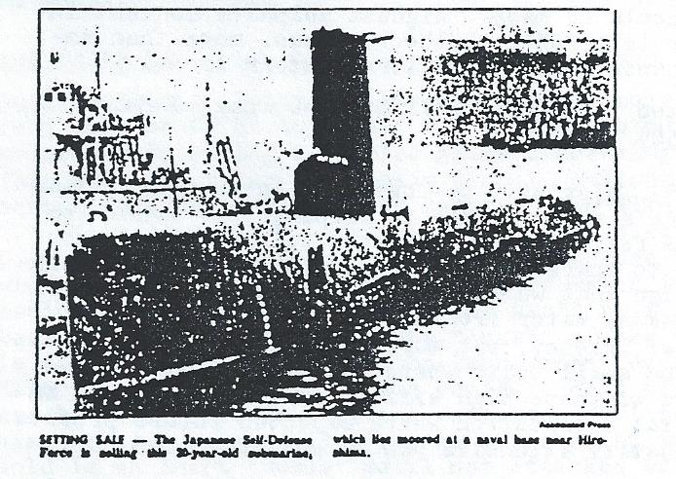
(From BUFFALO NEWS, 5 July 85. See “Live on a Submarine” chapter in LAST FRONTIERS ON EARTH.)

OCEAN FREEDOM NOTES, NUMBER 7
July 1987

GOUGH ISLAND
Gough Island lies in the middle of the South Atlantic southwest of Cape Town, South Africa, & southeast of the remote island of Tristan de Cunha, at 40°S, 10°W. It has a warm climate, abundant rainfall, & is covered with thick vegetation. There are no large land animals, but plentiful seals, penguins & seabirds. Gough has never been inhabited, or much disturbed by humans, & info about it is hard to come by, which makes it all the more attractive to some. A research expedition from Cambridge University, England, spent 6 months on the island in the 1950s, so extensive info about it is probably buried somewhere in the archives at Cambridge U. If there was a book written about this expedition, I haven’t yet come across it.

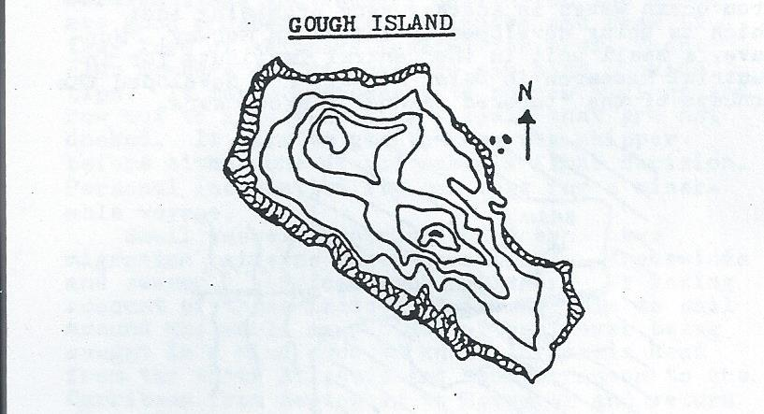

This poor map is based on the only map of Gough I have ever seen. It reveals that the island is of considerable extent, one of the larger uninhabited islands, but I don’t have a figure for its area. It rises up to 2 peaks with a saddle in between, like a 2-hump camel. The higher southern peak is over 3000 feet high. The coast is made up mostly of steep cliffs, but there is apparently a natural harbor or landing place on the east side.
Gough is a British possession & there is a South African weather station on the island, whether manned or unmanned I don’t know. If it’s an automatic weather station, as seems likely, S. African personnel probably visit once or twice a year to maintain it.
It seems to me that Gough belongs on the short list of most-desirable uninhabited islands.

ISLAND PROPERTIES REPORT
Island Properties Report is a monthly newsletter listing islands for sale, mostly in the Caribbean. They say: “We’ll help you find your villa, condo, land or business on the right island for you...Tell you what it’s like to live there...Show you how to rent your home for top profits...Help you every step of the way to turn your island dream into a rewarding lifetime reality.” Price: $39/year. Order from IPR, Route 4, Woodstock, VT 05091.

WANT TO BUY A USED SUBMARINE?
New York (AP) – An identified seller has a submarine for sale to “the discerning buyer.” The ad in the business section of Sunday’s NY Times said the de-armed sub was fully equipped & operational, can carry up to 70 passengers & crew & has a cruising range of 9000 miles. No asking price was mentioned but interested parties were assured the sub was “safe, reliable & excellent for either surface or underwater passage.”
“It’s not a hoax,” said Times spokeswoman Nancy Nielsen. “I haven’t seen the sub with my own eyes, but it went thru all of our checks.” She said she could not divulge the identity of the advertiser.
The Navy, which sells decommissioned subs for scrap or donates them to communities, denies putting this one up for sale. US Attorney Rudolph Giuliani said selling a submarine isn’t illegal.
(From BUFFALO NEWS, May 29, 1987)

PRIVATE ISLANDS UNLIMITED
Private Islands Unlimited is a firm that sells islands, in all parts of the world, for prices ranging from $20,000 on up. They offer advisory services for one year for $20, with more detailed info on any property for a “modest fee.” Contact: Donald Ward, 17538 Tulsa St., Grenada Hills, CA 91344. – Phone: (213) 360-8683.

OIL PLATFORMS
An item in EXXON USA, a magazine published by Exxon’s PR Dept, says there are now over 3500 oil platforms in place in the Gulf of Mexico. (I was surprised to learn there are so many, but the source seems reliable. –JS) The tallest stands in over 1000 feet of water. A recent development, the guyed tower, can be used in up to 2000 feet of water.

SUPER CRUISE: STARSHIP SLOWCOACH
Captain Ken Peterson writes to say: “I’m currently seeking 3 partners, ages 23 thru 50, male or female, for a multi-year photographic expedition exploring the tropical world.”
The 56 foot ship that will be used for this voyage is presently under construction in Maine, scheduled to be launched in June 1988. Participants will move to Maine & spend months until launch acquiring relevant nautical skills. The planned itinerary is south along the East Coast to the Caribbean to visit all islands, then west thru the Panama Canal to begin a circumnavigation of the world, visiting tropical islands & coastal nations. It’s estimated the voyage will last 5 years, but all decisions will be made jointly by the participants. All equipment and amenities will be state of the art & first class.
The price for all this, plus clothing, medical & dental care, complete is $465,000 per person. That price includes a share of ownership in the vessel. So if you have 5 years & $½ million to spare, & if this is something you’d love to do write for more information to: Captain Ken Peterson, 13 N. Crescent Drive, Eliot, ME 03903, & be sure to tell him Jim Stumm sent you.

SUVAROV ATOLL
Suvarov Atoll is no longer uninhabited. During 1986 the Cook Island Govt appointed official residents to live on the atoll & watch over the place. They are in daily radio contact with Raratonga to call in weather reports & any other news. An airstrip is also being built at Suvarov. At last word it had already been surveyed & was expected to be in service within a few months. I wouldn’t have thought there was enough land area at Suvarov for an airstrip, but I suppose the plan is to dredge the lagoon & build up part of the reef to create land for it. Suvarov lies in the direct line from Bora Bora to American Samoa, so it’s become a popular stop for yachts.
(Info from SSCA COMMODORES BULLETIN, Jan. 87, p. 35. For more on Suvarov see LF9 p.4 and “Uninhabited Islands” by Jon Fisher, p. 35.)

OCEAN FREEDOM NOTES, NUMBER 8
Oct. 1987

NOTES ON ISLANDS
By: Jan B.
*Of 7000 islands in the Philippines, approximately 6000 are uninhabited (some lack fresh water).
*There are 100s of islands off the coast of New Zealand that are not inhabited.
*There are (possibly) 1000s of islands off the coast of Australia that are uninhabited, many between Port Headland and Darwin on the northwest coast. Most of this coast has never been “chartered.” The admiralty charts show “numerous islands & reefs – not charted.”
I know a lady who sailed in this area for 7 years visiting many islands & seeing no humans for months or years. She sailed a homebuilt catamaran so she could ground it on the sand and/or mud flats at high tide. The area is very hot. Many islands have no fresh water.
*Coast of British Columbia and Alaska has many uninhabited islands.

FRESH WATER
The simplest system I’ve come across to provide reasonable quantities is the “Delbuoy.” A piston-type pump pumps sea water in & fresh water out thru a reverse osmosis membrane. This pump is designed to be anchored on the ocean floor & is powered by wave action that lifts & drops the float that activates the piston movement. Once installed it just keeps pumping. The mechanics of it are simple & straight-forward & should be buildable in any machine shop, or adapted from many “surplus” hydraulic pistons.
In prototype trials in the Bahamas, this pump provided water to an island for gardens, household use, etc. that saved the island owner several thousand dollars a year in fresh water that had been previously delivered by tankers. I’m convinced the same system can be adapted to shipboard models to provide fresh water by wave action near the ship.
The “Delbuoy” was developed under a “Sea Grant” program by Douglas Hicks at University of Delaware. Doug Hicks & the patent for the “Delbuoy” now seem to be “owned” by: International Science & Technology Institute, Inc., 2033 M St. NW, Washington, DC 20036. Communication with the Institute over 2 years indicates they have (as yet) not been able to put this device into production.
I personally think this device has “LOTS” of interesting possibilities for living free both on the sea & otherwise uninhabitable islands & coasts. Therefore, not being able to pry any info from the Institute and/or a finished device to take apart, I traced down the US patent. It is #4,512,886 issued to Douglas Hicks. Someone may want to explore this device & track down Douglas Hicks who is possibly not with U. of Del. anymore, but is reportedly working for the Institute at their lab in Delaware.
(Editor’s Note: The “Institute” may be Hicks own creation to profitably exploit his discoveries.)

OTHER INFO in my files:
*Grains, fruits, & vegetables that grow when watered with 100% sea water.
*Enclosed growing environments for year round growing in sub-arctic conditions.
*Underground houses of clay (adobe) fired in place to create monolithic structures (both very strong & life expectancy of 1000s of years). Also very useful for using materials available on site. It’s possible to dig the house (cave) to shape & then fire it.
*Growing in acidic peat soils with addition only of ground rock dust.
*Fuels from organic sources.
*Lots more for isolated survival-living systems.
My interest for the last 25 years has been self-sufficiency, appropriate technology, etc. I am not at the moment able to carry on my own projects as I am now a political prisoner in the California prison system.
(Editor’s Note: Letters to Jan B. can be sent c/o LIVING FREE, and will be forwarded.)

WAVE POWER HARNASSED
Island residents often must pay a high price for electricity generated by burning fossil fuels. Solar energy may provide an alternative, but islands outside the tropics may not have enough sunlight. Wind power is another option, but wind machines all too often are blown apart in the 1st good storm. Energy from ocean waves is another very promising idea which is being developed by a firm in Norway. Norwave, a small unit in the Central Institute for Industrial Research in Oslo, Norway, has developed the concept of the “tapered channel,” shown here.

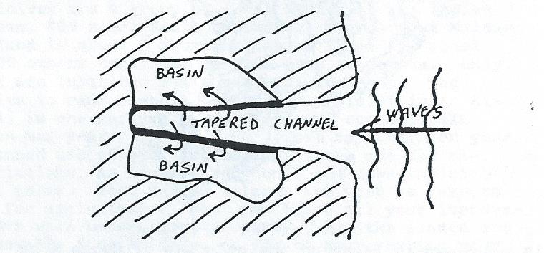

A suitable narrow inlet is found, or one is blasted out of a rocky coast. Concrete is poured to create a channel & basins on each side, of ideal shape as worked out on computers. The channel narrows & its floor rises toward the inland side. The basins on each side of the central channel are well above sea level.
How it works: Waves slamming into the coast rush up the channel, As the channel narrows, this bore of water has no where to go but up, & it’s forced to go higher & higher until it spills over into the side basins. So with each wave, seawater pours into these side basins creating small lakes that are well above sea level. The water from the basins is allowed to fall back into the sea after passing thru a high volume, low head water turbine that produces electricity. –It’s an elegant, simple, durable system; low maintenance, & no moving parts outside the powerhouse.
Norwave has built a small wave-power station along these lines on an island near Bergen, Norway. Their model site is producing 350 kilowatts of power at a cost of less than 8¢ per KWH, about half the cost of electricity from a diesel generator. They say their efficiency is 93%, but the design can still be improved, & the efficiency increased.
(Information from ISLANDS, July 87, p. 12)

OCEAN FREEDOM NOTES, NUMBER 9
July 1988

OCEAN FREEDOM THROUGH CREWING: Diogenes of Panarchia
Although most of the benefits of ocean freedom are probably only available to those who own boats, crewing can offer many advantages – particularly the opportunity to learn nautical skills. Thousands of small vessels cross the Atlantic and Pacific Oceans annually. Many of these vessels find themselves in need of crew members to help with sailing, cooking and navigation. Even an inexperienced person can be of use if the need is great enough and the person appears motivated and competent.
Boats over 45 feet long with cluttered decks, foreign flags and laundry hanging on the lines are good prospects. Ask skippers and crew if they know of skippers looking for crew. Yacht club members and dockmasters can also provide tips. It may be necessary to borrow a dingy and row out to likely-looking vessels that are not docked. It pays to get to know the skipper before either one of you makes a final decision. Personal incompatibility can make for a miserable voyage.
Small vessels crossing the oceans have migration patterns based on currents, tradewinds and seasonal hurricanes or cyclones. By taking account of these factors it is possible to sail around the world many times without ever being caught in a wind over 40 knots. Vessels head from the North Atlantic and Mediterranean to the Caribbean from September to November and return from March to May. Boats in the Pacific tend to head for Australia or New Zealand from March to November and return from March to May. Yacht races take account of these weather/current-influenced seasonal migrations, and the finish point of races is often a good place to find vessels in need of crew members for the trip home.
Despite the fact that so many small vessels make these long voyages across the oceans, piracy is exceedingly rare for the simple reason that the oceans are so enormous. A pirate on the open seas has a difficult time finding victims. The few pirates that exists tend to stay close to the coastlines of Columbia, Southeast Asia and Celebes.
Once you have reached your destination, it is often possible to get seasonal work in agriculture or tourism, or to teach English. WORK YOUR WAY AROUND THE WORLD by Susan Griffith (Writers Digest Books) is a good source of information about opportunities of this kind.
Also contact: Crew Unlimited, 2065 South Federal Highway, Ft. Lauderdale, Florida 33316 and Crewfinders, 2150 Southeast 17th Street, Ft. Lauderdale, Florida 33316.

LARGEST CRUISE SHIP EVER BUILT
Recently completed, like a floating grand hotel, with accommodations for over 2000 people. Picture this sailing under a flag-of-convenience, as an independent city-state.
(From BUFFALO NEWS, 2/14/88)

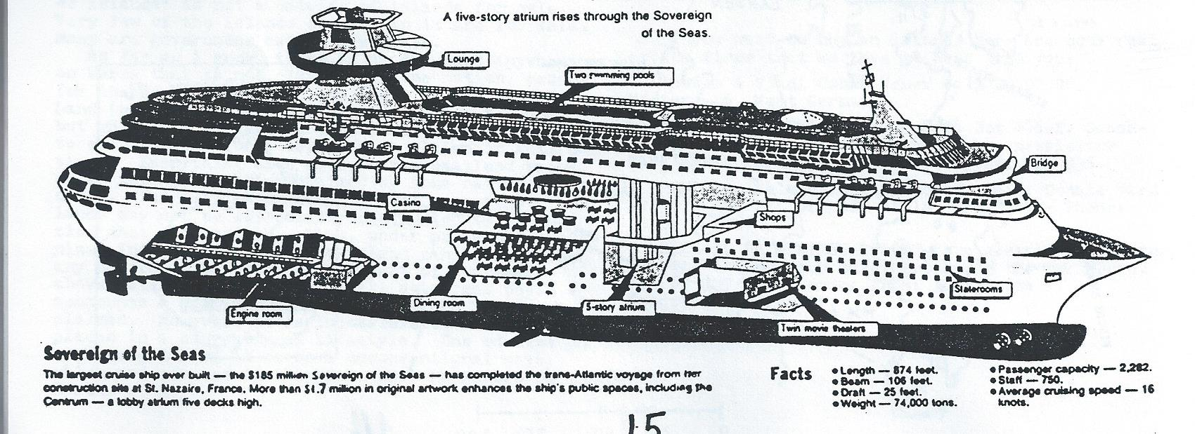

U.S. SET TO FLOAT “FORT” IN GULF

SEE BELOW FOR ARTICLE IMAGE

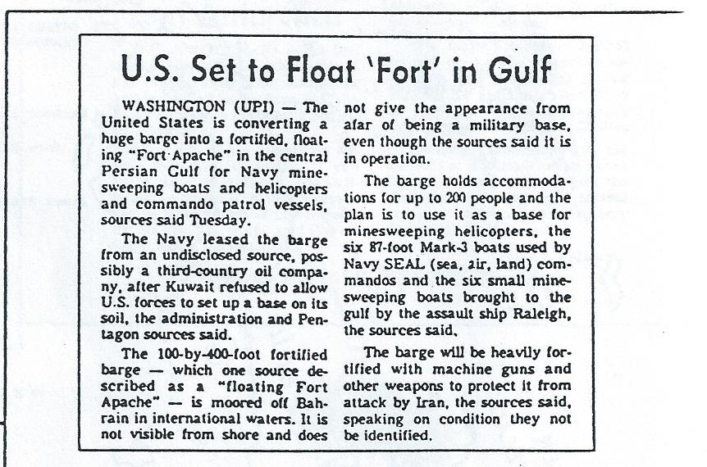

(From BUFFALO NEWS, 9/30/87)

COMMENT:
A residential barge like this could be anchored within a submerged reef that would serve as a breakwall to protect against ocean waves.

CONTINUE READING BELOW

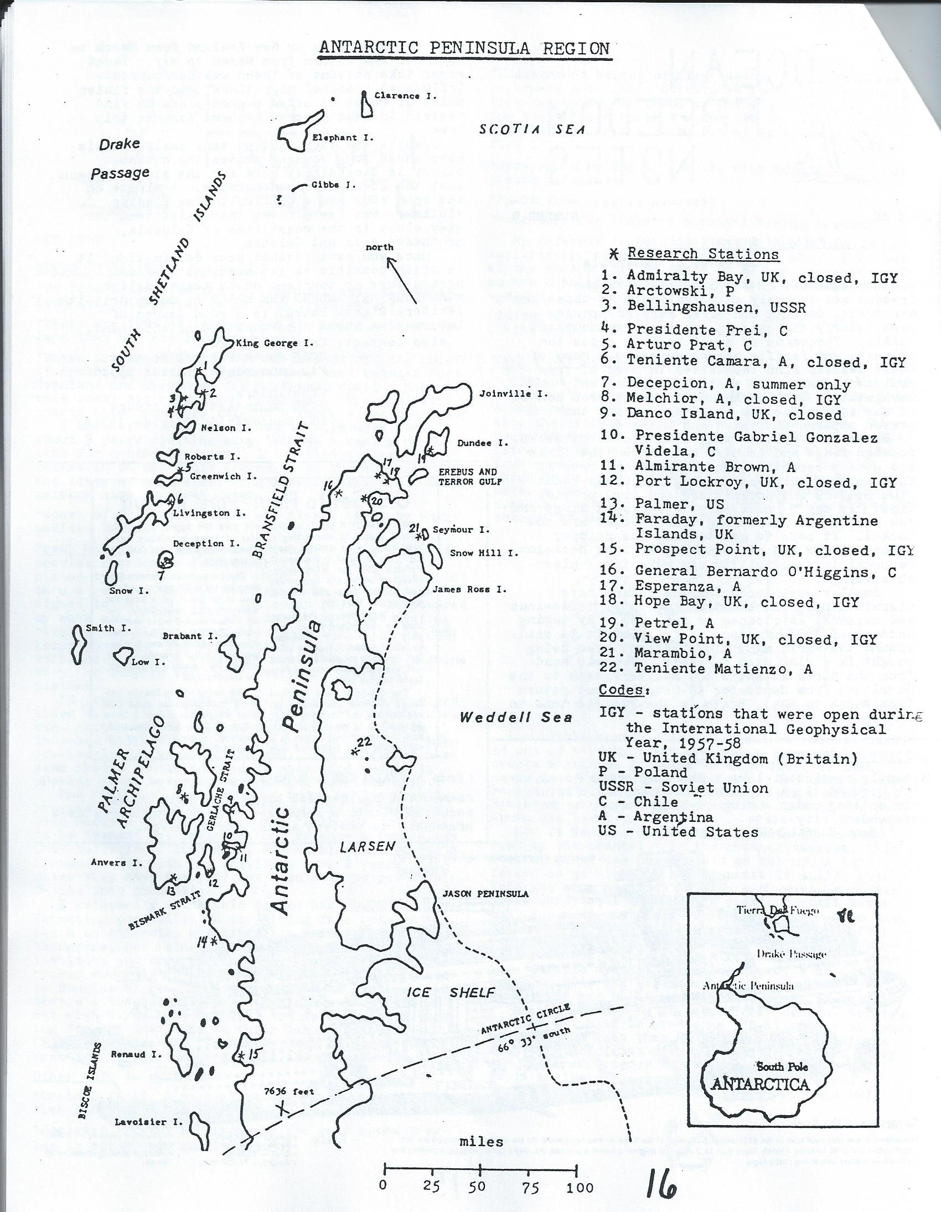
ANTARCTIC PENINSULA
The continent of Antarctica is roughly circular except for the 900-mile-long Antarctic Peninsula that projects northward toward South America. Geologically, the Peninsula is a continuation of the Andes Mtns of S. America. It’s inaccessible by sea on the east side where it is guarded by the ice-choked Weddell Sea & the Larsen Ice Shelf, but the sea on the west side is relatively ice-free & navigable for a short summer season. Even so, even the west side is not a hospitable coast. It’s mostly all glaciers reaching right down to the sea, except where rock cliffs rise almost straight up out of the water. In the interior, elevations reach as much as 10,000 feet. The Peninsula is mostly an ice-covered mountain range with bare rock only where the slope is too steep to hold ice.
This region has been much explored, exploited for fur seals & whales, & researched. Three nations claim it, Chile, Argentina, & Britain, though their claims remain in suspension as long as the Antarctic Treaty remains in force. These overlapping territorial claims are probably part of the reason why the density of research stations is so much higher here than in other parts of Antarctica, as Chile & Argentina especially maintain several stations each to make their presence felt.
Deposits of several minerals have been found on the Peninsula & nearby islands, though it has not yet been established whether any of these exist in commercial quantities. But traces at least of all of the following have been found: nickel, chromium, cobalt, copper, gold, silver, manganese, & molybdenum.
Antarctica’s highest temperatures occur along the northern fringes of the Antarctic Peninsula & the nearby islands, The daily average summer temperatures there remain about freezing for 1 to 4 months, & daily highs are sometimes well into the 40s F. There is some rain in the summer. The east coast of the Peninsula is colder because the mountains block the flow of the prevailing westerly winds off the warmer ocean. Except during the short summer, temperatures in the Peninsula region vary between 0° and 32°F, with occasional colder periods down to -40° below zero.

SEE BELOW FOR IMAGE
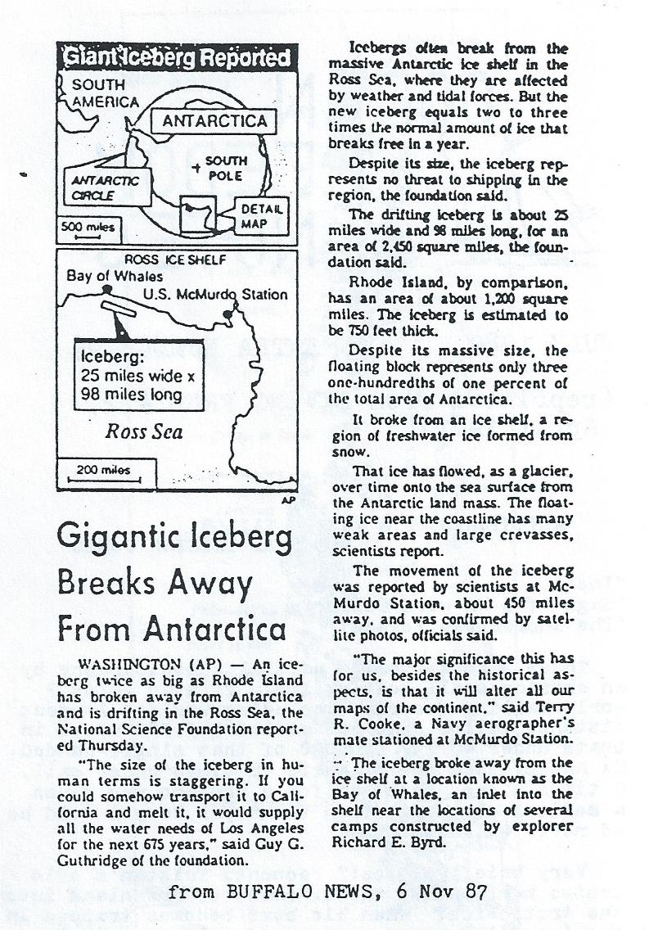

HE WANTS TO BUY AN ISLAND
Dear Mr. Stumm,
I am interested in buying an island. Send me your catalog of islands for sale. I am particularly interested in properties that are not under the jurisdiction of any established nation.
Island Buyer

Dear Island Buyer,
The book we have for sale “Uninhabited & Deserted Islands” is not a catalog of islands for sale. Very few of the islands covered in it are for sale. Many are government nature preserves.
As far as I know, there is no dry land anywhere on Earth that is not claimed by some nation, except for the sector of Antarctica known as Marie Byrd Land (which other nations have set aside for USA, but which USA refuses to claim, as it doesn’t want to encourage national territorial claims in Antarctica.) Everything else, down to the smallest speck of an island, has been claimed by some nation or other. The best we can say is that some remote islands may not be effectively controlled by the nations that claims them. Also, under presently recognized international law, no island can be owned by any nation unless some little part of it remains above water at high tide, so all submerged reefs & seamounts & similar underwater features remain unclaimed. However it is impossible to live in such places in a conventional lifestyle. One could live on a submerged reef in several unconventional ways, which are covered in the book “Last Frontiers on Earth.”
If you want to buy an island, here are some real estate firms that would love to hear from you:
*Boehm & Vladi GmbH, Neuer Wall 2, D2000, Hamburg 36, West Germany.
*Rare Earth Enterprises, P.O. Box 946-x, Sausalito, CA 94966. They also publish a newsletter RARE EARTH REPORT, 6 issues per year, for $36.
*Private Islands Unlimited, Contact: Donald Ward, 17538 Tulsa St. Granada Hills, CA 91344 – Phone: (213) 360-8683.
*ISLAND PROPERTIES REPORT is a monthly newsletter listing islands for sale, mostly in the Caribbean. Price: $39/year, order from: IPR, Route 4, Woodstock, VT 05091.

OCEAN FREEDOM NOTES, NUMBER 9 ½
July 1989

(Reprinted from LIVING FREE #12, April 1981)

ADVENTURES OF A MASTER SAILOR: BOOKS BY TRISTAN JONES
“Ice!”
“Saga of a Wayward Sailor”
“The Incredible Voyage”

These 3 books form a partial autobiography by an amazing small boat sailor. Tristan holds 9 world sailing records, including world’s longest distance sailor. He has sailed 345,000 miles in boats under 40 ft, 180,000 of that single-handed. He has crossed the Atlantic 18 times under sail, 9 times alone. Not bad for a man who was given a medical discharge from the Royal Navy & told he would never walk again.
Very briefly: “Ice!” recounts Tristan’s solo cruise north along the E. coast of Greenland into the Arctic ice. When his boat becomes trapped in the ice, it becomes a story of polar survival.
“Saga...” brings us Tristan knocking around Europe in small boats.
“The Incredible Voyage” starts in NYC, takes him to Israel, then S. on the Red Sea (thru hostile Arab waters just after the 6-day War), along the E. coast of Africa, across the Atlantic & up the Amazon River, back to the Atlantic, the Caribbean, Panama Canal, and down the W. coast of S. America, overland up to Lake Titicaca, where his is the 1st ocean-going vessel ever to sail on that highest body of water in the world, then on to the Paraguay & Parana Rivers, where he is the 1st ever to sail in the Mata Grosso, which is one of the most impenetrable swamps in the world, still largely unexplored. Along the way, in all his books, Tristan vividly describes the places he sees, & the people he meets, & tells us what it’s like to sail a small boat in various waters.
Tristan writes as he lives: boldly, directly. His books make fascinating reading. He reveals himself as a person who doesn’t endure bureaucratic restrictions gladly. He mentions a bit of smuggling here & there & times he travelled in certain places w/o all the official papers the local bureaucrats might have wanted him to have.
Cruising the oceans in a small boat can be a very free way to live, & Tristan shows that you don’t have to be wealthy to do it (but it helps). However, cruising on “the shorts” is no life for anyone who requires security, physical or financial. If you think you might ever go to sea in a small boat, I would say that these books are an essential part of your education. And armchair travelers will find them gripping reading. Highly recommended. Tristan also has published another autobiographical volume “Adrift” which I haven’t read yet.

ISLANDS OF SOUTH CHILE – AN UNTAMED FRONTIER
(Transcriber’s Note: A map identifying the islands/locations described is included below.)
On the W coast of S. America, from the S shore of the Island of Chiloe at 43 S latitude, all the way to Cape Horn at the tip of Tierra del Fuego at 56 S, a vast labyrinth of islands & steep sided fjords extends for 1000[s] [of] miles. This region has been mapped only from the air & sea & otherwise remains largely unexplored, unsurveyed, & unpopulated. The region from Chiloe to Puerto Natales., a town (pop. 11,500) at the northern limit of T. del Fuego, which is a distance of about 600 mi, comprises the Chilean province of 48,000 in 1970, almost entirely on the mainland. The provincial capital is the town of Aysten, on the mainland river of the same name, which had a population of 7140 in 1970. This is the most populous settlement in the province.
One reason settlers have been slow to move into this area is because the broken terrain with steep mountains, fiords, & some glaciers running into the sea, makes it impossible to build a road running the length of the province. A motorist has to cross the Andes & travel N or S thru Argentina. On the Chilean side, the only way to get from Chiloe & pts N to places in Aysen province or to P. Natales & pts S is by air or by sea.
On these islands themselves the only settlements that I have seen mentioned are Melinka on Ascension I. with a pop. of 450, P. Lagunas on Melchor I, which has a radio station, & P. Eden on the E side of Wellington I, which was a weather station & seaplane base in the 1950s. In addition there may be a few villages of Alacaloof canoe-Indians, although they numbered only about 300 in 1950 & were dying out. And in certain seasons, one may see a few fishermen & otter & seal hunters along these shores.
The climate on these islands is cold & wet. These mountainous, misty islands are covered with dense forests of both evergreens & deciduous species. In some places, bamboo grows in impenetrable thickets. And an abundance of thorny shrubs also impede surface travel.
These woods are home to numerous birds including, among others, hummingbirds, parakeets, & woodpeckers. The mammals found here include deer, fox, opossum, puma, & various rodents. Along the coasts of one finds fur seal, sea otter, & nutria (similar to beaver) which have valuable fur, & seabirds & shellfish.
From the Island of Chiloe on S, this region includes the Chonos Archipelago which runs for 130 miles & includes 1000s of islands. Below that lies Taitao Peninsula, which is almost an island since it’s connected to the mainland only by the narrow Isthmus of Ofqui. The southern shore of the Taitao is washed by the Golfo de Penas (gulf of troubles), a turbulent bay where many ships have been lost. No outlying islands shelter this coast so the waves roar in unimpeded from the open Pacific & from Antarctica 1000s of miles away.
South of this gulf one finds mostly larger islands with even fewer people than the few who live on the islands N of Taitao. This area has been described as: “a vast maze of islands & channels where there is no sign of human life to intrude upon the grandeur & desolate solitude of nature.” These more southerly islands often run to several hundred sq. mi. in area & they rise up to a couple 1000 ft. The largest island in this area is Wellington, which is 100 mi. long by 15 to 25 mil. wide & has a highest elevation of 3300 ft. Wellington is mountainous, & has glaciers, swamps, & forests. Fjords deeply indent its coast. There is a tiny settlement named Puerto Eden on Wellington’s E coast, but it is otherwise uninhabited.
Further information on the major islands running as far S as the Strait of Magellan is given in the table below. There are still other uninhabited islands lying S of the Strait in the province of Tierra del Fuego, but, since they have an even harsher sub-Antarctic climate, we needn’t look too closely at them while these other islands lie empty & unused at more temperate latitudes further N.

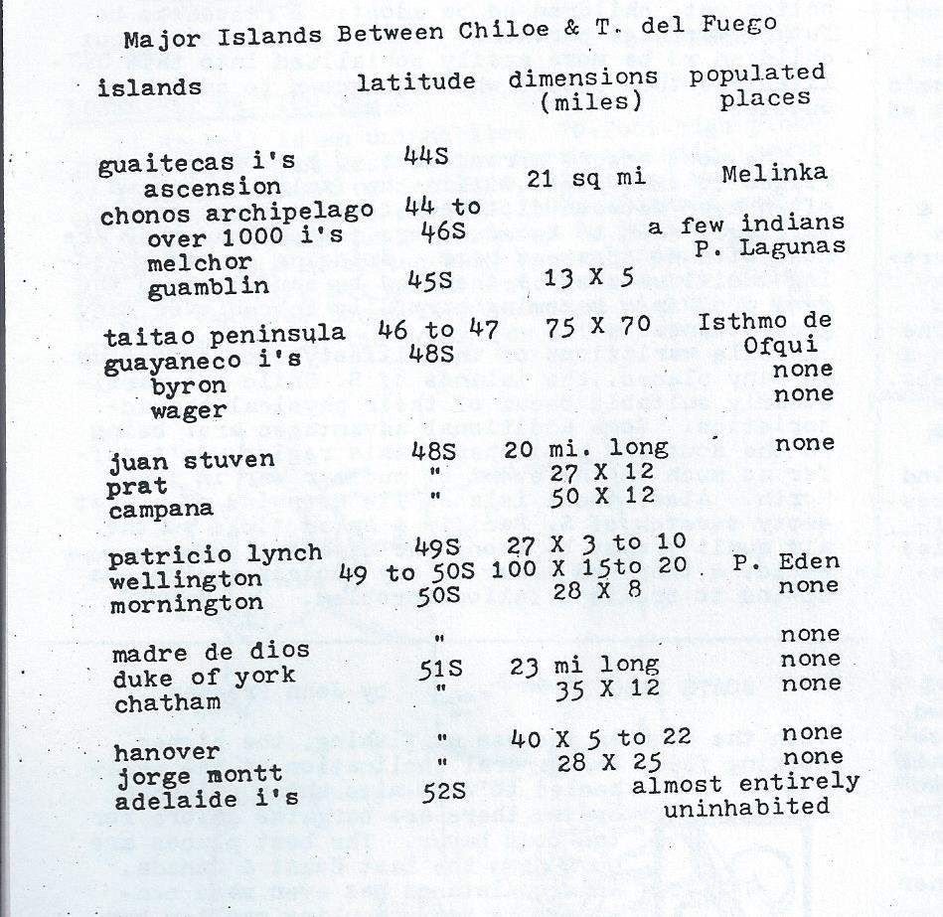
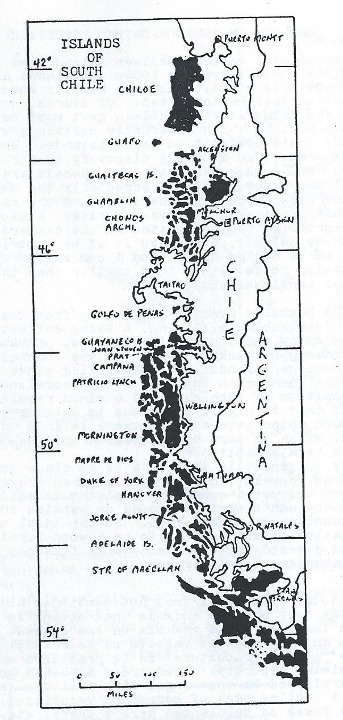

SELF LIBERATION WAYS: THE BURROW-SMITHS OF S. CHILE
(The following is part of an article by El Ray [Rayo/Tom Marshall] which was published in INNOVATOR, Autumn 1969. This lifestyle description is a composite & extrapolation, not a description of actual, existing persons – JS)
“The Burrow-Smiths want complete independence but believe that with enough knowledge & initial equipment they can self-sufficiently maintain late-19th-century technology. They also believe there is no substitute for distance from the American Leviathan & other coercivist power centers. They have secretly constructed & furnished a large underground home & workshop beneath an uninhabited island on the southern coast of Chile. Their facilities include dry dock storage with well-camouflaged entrance for an old 60 foot sailing vessel. In summer some of the Burrow-Smiths sail to small isolated communities away from their immediate area, where they offer repair services not locally available; this provides a small but adequate income source, initial equipment having been paid for out of savings.
“The Burrow-Smiths eat staples plus sea food & what they forage on nearby islands. They are also experimenting with underground hydroponics; the cold wet climate & a desire for unblemished concealment preclude surface agriculture. For power they have a small hydroelectric plant. They produce charcoal for smelting; the island is heavily timbered. They hope eventually to find ore deposits nearby, but in lieu of that, will carefully salvage & reclaim their own worn out equipment plus what scrap they find in their travels.
“The Burrow-Smiths want isolation from what they believe is a dying civilization, but to hedge their bets the isolation will be in one direction only; children become fluent in several languages & dialects so that they may ‘pass’ easily within both Anglo & Latin countries. In form the family is modified “line marriage” – perpetuating relation suggested in Robert Heinlein’s ‘The Moon is a Harsh Mistress.’ Many adopted as well as biological children assure a large genetic pool. When they become too numerous for a single house they intend to duplicate key equipment, separate into 2 groups, & launch a 2nd similar community elsewhere.”

COMMENTS ON “BURROW-SMITH” LIFESTYLE
Concealment on a S. Chilean island does seem feasible since there are 1000s of islands along this 600 mile coast, which are heavily wooded & almost entirely uninhabited. Of course, contact with the authoritarian Chilean govt must be absolutely avoided. I’m reasonably certain govt forces don’t set foot on these islands. Under the thick tree cover avoiding discovery by air should be easy. But I would guess that the channels are patrolled by govt gunboats, especially the sheltered inside passage between the islands & the mainland, so that’s the area of greatest risk. A secret home probably should be located on the seaward side of these islands, & even so it would be best if one’s boat could be hauled up on land & concealed. That would be easier to do with a boat smaller than the 60-footer mentioned above.
The Humboldt Current driving from the S, & the tides ebbing & flowing, & being deflected & funneled by the obstructing islands, probably create strong & tricky currents in the channels between these islands. The prevailing winds blow off the open ocean onto the rocky shoreline. The combination of such currents & winds results in a coast that is highly dangerous to sailing vessels. So such ships have avoided these islands in the past, which is part of the reason why they have never been inhabited.
My judgement is that this is no place for wind powered vessels; fuel-burning engines are a necessity. And yet a community aspiring to self-sufficiency wouldn’t want to depend on outside supplies of gasoline or diesel fuel. So the ideal transportation solution seems to be a wood-burning steam powered launch, fueled with firewood from the abundant local forests.
Another source of food not mentioned above would be the deer & other animals that abound in these rain forests, & sea mammals on the coast. Small food animals such as rabbits could be raised. Also some “proto-agriculture” could be practiced w/o compromising security: Food trees & bushes growing naturally could be encouraged with a little fertilizer & cutting back of competing vegetation. Other food trees could be planted here & there, etc.
On these large islands with their high elevations & abundant rainfall, there would be ample water power to supply all domestic energy needs. Small hydropower systems could easily be concealed beneath the vegetation, or even completely underground, if that was deemed necessary.
Running a repair business serving outsiders poses a much too serious threat to security in my opinion. It would be better not to have that much contact with outsiders. Furthermore, that may not even succeed as a business venture, since about the only customers one can find on these shores would be a few scattered Indian villages. Members of a secret community probably should stay away from the few larger ports to avoid attracting the attention of some govt functionary. A preferable alternative source of income would be from selling furs from sea otters & fur seals.
In order for children to pass in outside society, more than just a knowledge of the language would be required. They would need to have a whole repertoire of skills, some quite subtle. They could only get these skills by living outside. Perhaps older children or young adults could go outside to school or to work. But some of them will find the “bright lights” seductive & will not return. Those who do return may have divided loyalties & be a security risk. All in all I’d be inclined to avoid all contact with outside except for those people who specialize in “import & export,” in going outside to buy, sell, or to gather information.
I’ve lived in collective houses myself & seen friends experiment with group relationships. Based on that I’m skeptical about the chances for success of “line marriages” or other unusual arrangements. The form I would rate most likely to succeed would be mostly monogamous unions within an extended family made up of numerous blood relatives (and some persons adopted in), headed by a strong patriarch or matriarch. Young people could go out to find marriage partners who would be brought in. Or better yet, children could be adopted & raised to be future marriage partners. That’s preferable because children would be more easily socialized into this lifestyle than people who have grown to adulthood outside.
The most secure arrangement would be for most marriages to take place within the family, which would often mean between close relatives. First cousin marriages used to be much more common than they are now, with no apparent harm. Bringing in new breeding individuals now & then should be enough to keep the gene pool from becoming harmfully inbred over many generations.
While variations of this lifestyle could be set up in many places, the islands of S. Chile are particularly suitable because of their physical characteristics. Some additional advantages are: being in the southern hemisphere, this region wouldn’t suffer as much in the event of nuclear war in the North. Also, these islands lie downwind of a vast empty stretch of S. Pacific & Antarctica, so the air quality must be among the cleanest in the world, & there would never be any nuclear explosions upwind to create a fallout problem.

BOATS (1980) by John Freeman
With the drop in success at fishing, the higher docking fees, & a general inclination of the well-heeled to want nice shiny polished boats, there are bargains galore for the boat buyer. The best places are up & down the East Coast & Canada. An acquaintance has even made considerable money hauling smaller bargain price East Coast boats across the country – at the moment he is paying $35 a month at a Virginia Beach yacht club & living on a 35 ft boat he got for less than $1000 – where could you get better rent than that inland?
The West Coast berth & slip fees are usually atrocious but a number of persons beat that by staying anchored out a ways, & rowing a dingy. No one in their right mind ties up at Latin ports along the West Coast. Port authorities are very greedy, corrupt & dishonest. After weeks of picking around in the terrible weather of the “below Mexico” coast, I can also validate the claims of this being a very dangerous area weather-wise. After a recent tour around the waterways of Asia, I just wished life wasn’t so cheap in this area of the world. –For the vonuer who uses enough Grey Matter, boating is a good answer.

OCEAN FREEDOM NOTES, NUMBER 10
Dec. 1989

LONELIEST BRITISH ISLES
1) Rockall is an uninhabited, 70-foot-high pinnacle of rock that lies in the North Atlantic, south of Iceland, & west of Scotland, 225 miles west of the Hebrides Islands, at 58°N, 14°W. Rockall was claimed by Britain as a territory in 1955. Such an isolated rock, inhabited only by seabirds, has no value in itself, but govts are eager to lay claim to such features because it gives them rights to natural resources in the ocean for 200 miles around.

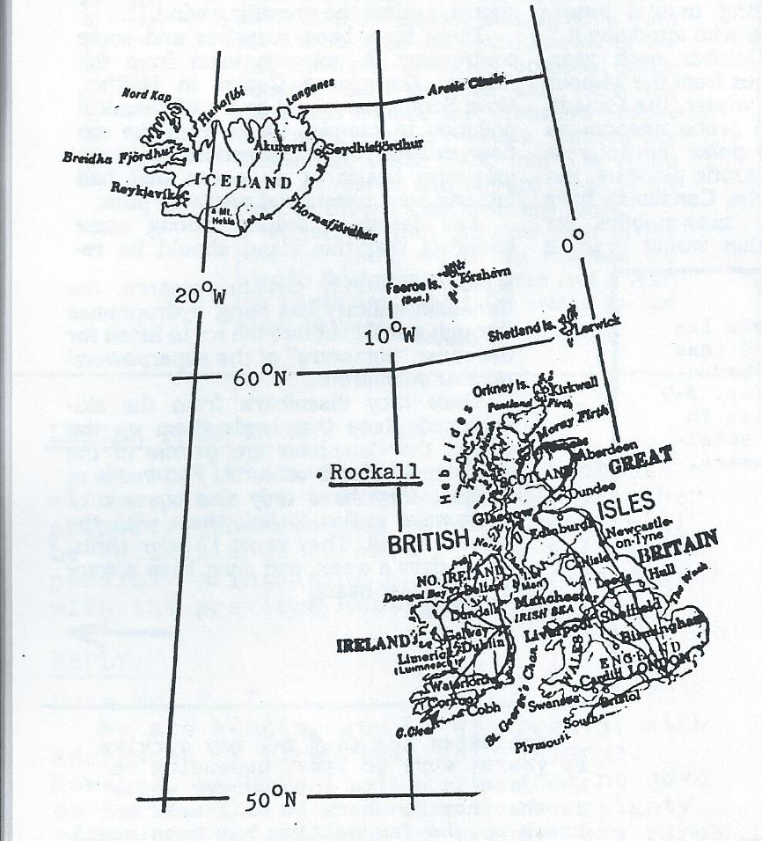

2) St. Kilda is the main island of the westernmost group of outer Hebrides, lying 42 miles northwest of North Uist, well away from the other Hebrides at 57°50’N, 8°30’W [sic]. St. Kilda is 3 miles by 2 miles, rising to 1372 feet in the northeast, with precipitous cliffs & a landing place on the south side. It was continuously inhabited from ancient times until 1930 when the surviving population of 36 was taken off, at their own request, & moved to Scotland. It is now a bird sanctuary. The island, also known by its Gaelic name Hirta, has been the property of the Macleods clan for centuries. The group also includes the smaller islands of Boreray, Dun, & Soay. Boreray lies 4 miles northeast of St. Kilda & is 1 mile by ½ mile in size.

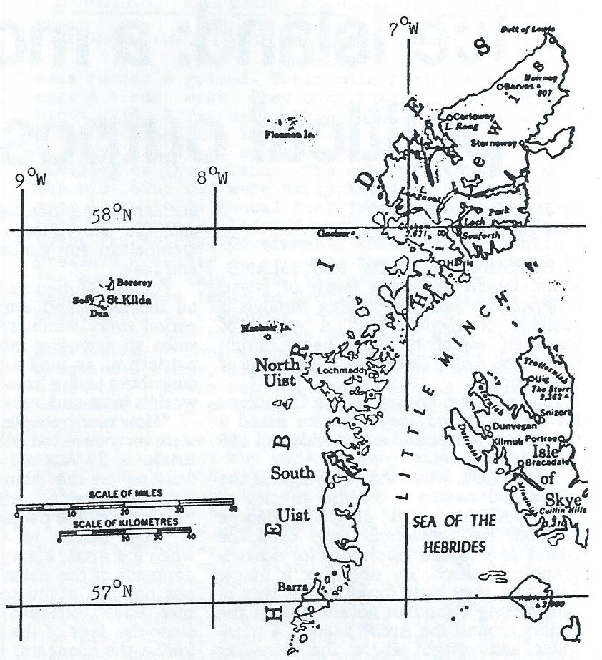

An eye-witness account of St. Kilda is provided by Tristan Jones in his 1978 book “Ice!” He says on page 124:
“I spied the mighty capsized cliff of Boreray, the most remote part of the British Isles. I hove to, had breakfast, then worked into Village Bay, where there had once been a settlement.
“As I lowered the mainsail, the 12 foot spar fell onto the deck with a sharp noise.

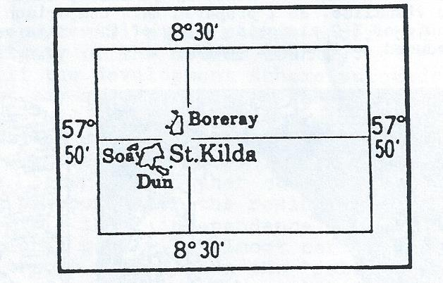

At this, a MILLION birds lifted up from the cliffs, which rise over 1400 feet straight from the ocean, & darkened on the moon sky. They were sea birds of all kinds. That rise of life from the white cliffs of Dun & Boreray was so violent that I was genuinely frightened in case they should attack the boat.
“The granite cliffs were white with bird shit. The sky was dark with rainclouds, which swept low over the lonely peaks of grey Hirta, the main island. From the deck, I had seen sheep climbing the steep cliff faces, looking like goats.
“I went ashore & looked around the old village. Here, people had lived from the Iron Age on, right up until 1930. In ancient times, they were the most isolated people in the Western world. Their life was very tough indeed. They could not fish from boats because there was no wood for boat-building, so they fished from the rocks, where great Atlantic seas rushed & gushed. Their main food was birds’’ eggs & birds’ meat. They made their clothes out of birds skins & feathers. Then sheep were introduced & for a while life improved.
“Thru all these centuries there were only 3 families on the islands. The only visitors, from the mid-1800s on, were stray travelers coming to rest & the twice annual boat from the mainland. In 1912 influenza killed off many on the island. In 1930, the British Government, under strong public pressure, decided to evacuate the island. All 36 of the surviving islanders (the population in 1850 had been 110) were taken to Scotland & eventually they drifted off to disappear in the slums of Glasgow.
“All the thatched roofs had blown away from the old cottages. Inside tough grass was growing. The preacher’s house, biggest house in the village, still had its tin roof. I looked around the tumbled stones of the 3 churches, then made my way back to the boat.
“How had Iron Age people reached these remote rocks I wondered? Why were so many bird beaks on the floors of the cottages? That last I figured out: they had used the bird beaks in place of wooden pegs, to fix the rush thatch to the roofs.
“St. Kilda is now (1977) a British Government wildlife reserve, & there is a rocket tracking station on the main island of Hirta. I am told there are even more birds there now!
“I watched the moon set beyond the stupendous cliffs of Boreray, a whole island tipped over on its side. Cliffs 1500 feet high, ghostly white under the moon, with millions of skuas & guillemots clinging to the ledges, so many that the black granite rock looked like some spiritland rearing straight up into clouds.”
(Jones visited St. Kilda in 1959 while sailing alone from Scotland to Greenland.)

LETTER FROM THOMAS R.E.
We are interested in making contact with sellers of island property, or other property, wherein the “sovereignty” will be relinquished as part of the sale while possibly maintaining a protectorate status with the previous host government.

REPLY:
Dear Mr. R.E.,
We are sending you LF 45, page 5, with addresses of firms that sell islands. However, we have to tell you that no govt on Earth will sell land with sovereignty to any private person or group. Very rarely there will be a sale of sovereignty to another govt only. The only way you can acquire sovereignty to presently-habitable-land is to wage war & take it by force. If you are not willing or able to do that, then I’m afraid it can’t be done.
The best a private firm may be able to do is to negotiate a Freeport agreement with a govt, promising to economically develop some impoverished part of that govt’s national territory. Such an agreement will typically abate some taxes for a specified period of years, & will give the first some quasi-govtal [governmental] powers, but the Freeport will still remain under the sovereignty of the mother country.
If the development scheme succeeds, the govt may abrogate the agreement & take back full control of the Freeport even before the date when the Freeport agreement is supposed to expire. It might be possible, before the mother country takes back the Freeport, for the residents of it to proclaim their independence. But then the national govt will almost certainly send in troops to put down the “rebellion,” so a war for independence will have to be fought to make the proclamation effective.
So in this case as well, obtaining sovereignty requires war. Existing nations are not eager to see upstarts entering their exclusive “club,” so they make the entrance requirements high. You have to kill like a govt as a minimum requirement before they will let you into the club of nations.

ICE ISLAND
In 1987 a gigantic chunk of ice broke off the Ross Ice Shelf in Antarctica & became a separate floating island (see LF45 p.5). This iceberg, designated B-9, at last report had drifted about 200 miles NW to the middle of the Ross Se. B-9 is so immense, about 20 miles by 90 miles, that its size is hard to visualize. So I prepared this comparison of a satellite photo of B-9 along-side a map of the state of Delaware, both reduced to the same scale:

SEE BELOW FOR IMAGE

Estimates are that B-9 may survive 10 years, more or less, depending on how fast it drifts into warmer water farther north, where it will melt & break up. So far melting has been negligible. It will last longer if it runs aground & gets stuck at a high (cold) latitude, which it may do since it extends about 750 feet below waterline, in addition to rising another 150 feet above the water. Like all Antarctic icebergs, B-9 is generally flat on top so that a plane with skis could probably land on it as it is, & an unimproved ice runway could easily be constructed.
Big as it is, B-9 is nowhere near record size for an iceberg. That distinction is held by a berg that was sighted in 1956 that was 208 miles by 60 miles, for a total area of 12,000 square miles.
(Photo & info from ISLANDS, Feb. 89)

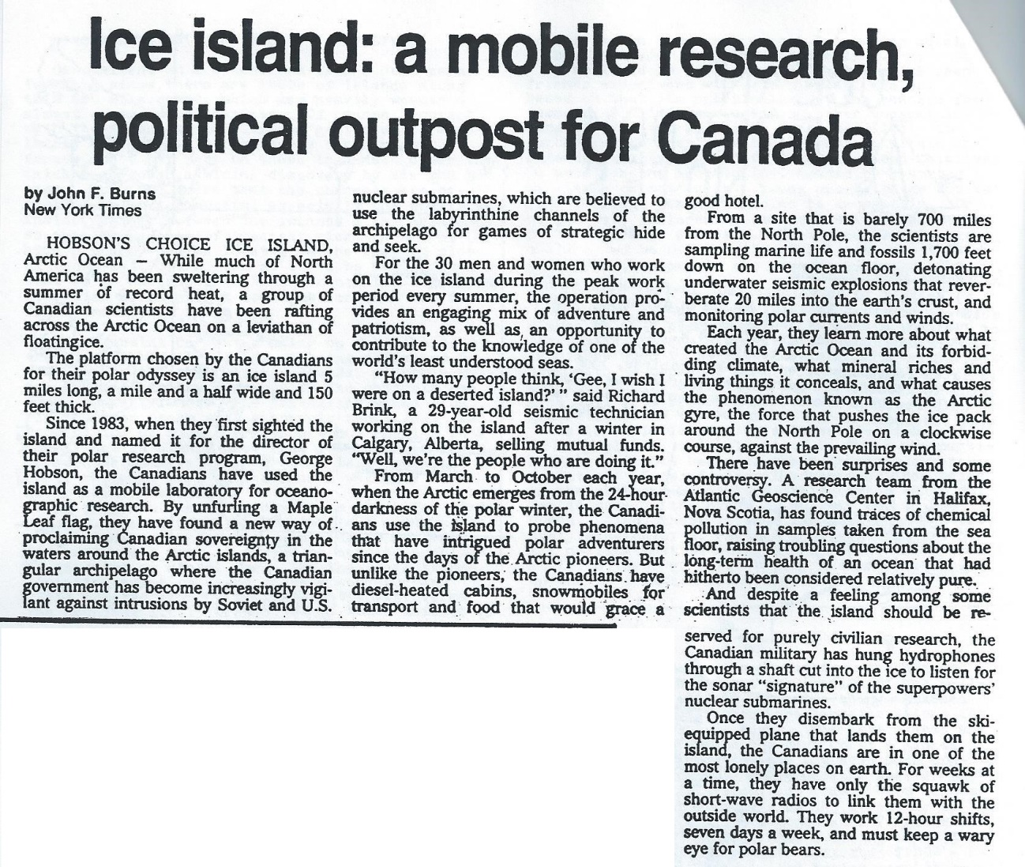
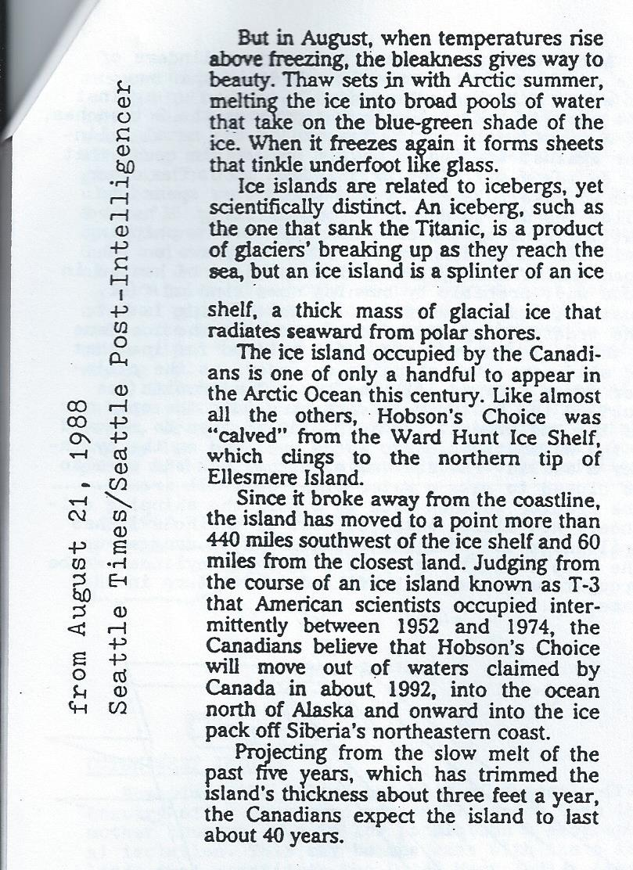
OCEAN FREEDOM NOTES, NUMBER 11
May 1990

ANTARCTIC ICE MINING
Many parts of the world are suffering from critical & growing shortages of drinking water. Yet a virtually unlimited supply of water in the form of fresh water ice exists in Antarctica, where 90% of the ice in the world may be found. Every now & then someone suggests towing Antarctic icebergs to some part of the world to relieve a water shortage. The problem is that icebergs are irregularly-shaped & ungainly to tow. Worse than that, a large part of the iceberg would melt enroute, especially if it’s taken across the tropics to a destination in the northern hemisphere where most people live.
It may be a better idea to put Antarctic ice into some kind of water-tight shipping container. The shape & dimensions could be designed for easy transport, perhaps by towing, or by stacking up on container ships. Then the ice that melts en route would not be lost but would arrive at the destination as liquid fresh water. I have worked out the details of how the job might be done speedily & efficiently.
An ice quarry would be set up near the ocean on some large expanse of fresh water ice in Antarctica, either on an ice sheet like the Ross Ice Shelf, or on a huge, flat-topped Antarctic iceberg (see LF 54, pg. 5). The ice would be quarried by means of horizontal heat drilling. Scientists already use vertical heat drilling in Antarctica to extract cores a few inch in diameter & 1000s of feet deep in order to learn about ancient atmospheric conditions by studying tiny bubbles of air frozen into the ice eons ago. My idea is to take that already-proven process, lay it over on its side, shorten the length, vastly increase the diameter, & use the shipping container itself as the drill casing. Here are the details of how it would be done:

HEAT DRILLING
First, 2 parallel trenches would be cut into the ice. This would be done using ice milling machines such as those that have already been used in Antarctica to construct the New Byrd Station. These trenches would both be cut to the same depth & their depth & distance apart would be determined by the dimensions of the metal cylinders used in drilling the ice & shipping it to market. These shipping cylinders should be as large as can be conveniently handled for economy of scale. The depth of the trenches would be a little greater than the diameter of the shipping cylinders & the distance between the 2 trenches would be slightly less than the length of the cylinders. One trench would be wide enough to allow maneuvering room for heavy equipment (tractors) & there would be a ramp leading down into it from the surface. The other trench would be simply a narrow cut.
After the trenches are prepared, cylinders or ice would be cut out of the ice sheet in this way: An empty shipping cylinder would be placed up against the uncut block of ice that separates the 2 trenches at a right angle to it. The end of the metal cylinder against the ice would have a removable cover that would be taken off, leaving that end open. The other end would have to have a valve that could be opened to allow the air to escape during drilling. A heated cutting ring of the same diameter as the shipping cylinder would be temporarily fixed in place on the open of the cylinder. This ring would be heated in some way, probably by burning some kind of fuel, just hot enough to melt ice. While the ring is hot, the tractor would push the cylinder into the ice-face & the heat ring would melt out a “piston” of ice that would slide into the shipping cylinder, as the cylinder moves forward, filling the cylinder with ice just as the heat ring breaks through into the open air of the 2nd trench. The heat ring would then be removed & the water-tight cover would be replaced on the cylinder & sealed. The air valve on the back end would also be closed to make a water-tight seal all around. The tractor would then back up & pull the shipping cylinder, now filled with ice, out of the hole it has drilled in the ice. The cylinder would be dragged up the ramp to a storage yard & and an empty cylinder would be brought back down to be filled in its turn in the same way.
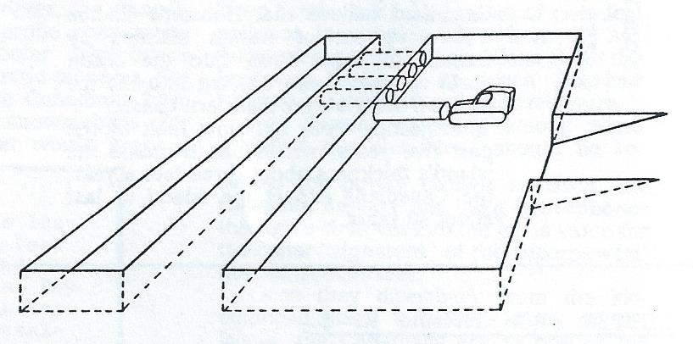
These ice-filled containers would be sent by sea to markets anywhere in the world. The seaward edges of ice shelves & icebergs in the Antarctic are usually nearly vertical cliffs that may be 100s of feet high. To get the shipping cylinders down to sea level would require either a long ramp, or a crane extending out over the edge of the cliff. These containers could be stacked up on ships. Or, maybe a better idea, they could be fastened together end-to-end & made into long trains with flotation cells if needed so they would float on the ocean, so they could be towed by ocean-going tugs, perhaps 1000s of miles to market.
The destination would be an ice-port that could be built on any seacoast. The containers would be hauled ashore & emptied. As a bonus, the ice could be placed 1st into insulated warehouses & exploited for refrigeration & air conditioning while the ice melts, before being consumed as water. Small amounts of water could be shipped inland by tanker truck. Larger amounts would be distributed more efficiently by pipeline.

DESTINATIONS
1) Southern California, where there is both a need for fresh water, & plenty of wealth to pay for it.
2) Australia, a short haul from Antarctica. An ice-port could be built on the south coast of Australia with pipelines running north & west into the driest areas. These regions could become as densely populated & prosperous as California once they had an assured supply of abundant fresh water.
3) Middle East. Saudi Arabia & Kuwait probably don’t need Antarctic water since they have the resources to get all the water they require by desalinating sea water. But other countries in the region are not as lucky. It’s estimated that the population in that area will double by the year 2010, & they’ll need twice as much water as they use now. So, ice-ports could be built somewhere in the Persian Gulf and on the Red Sea coast, with pipelines running to Jordan, Israel, Syria, Iraq, & Egypt.
4) Africa. Ice-ports on the east & west coasts could feed pipelines running into the sub-Sahara & even into the Sahara Desert itself. Antarctic water could be piped in to refill Lake Chad which is rapidly drying up.
5) Islands. “Icemen” could sail around routes of islands that lack dependable supplies of fresh water, dropping off containers of icewater & picking up the empties. Empty containers from all iceports would be returned to Antarctica to be refilled.

DUTCH WEST INDIES
Sometimes the island colonies of a mostly-free country offer even more personal freedom than the mother country, due to low population & geographical isolation. This may be the case with the 6 islands that constitute the Dutch West Indies (aka Netherlands Antilles). These islands fall into 2 groups: the Leeward, or ABC Islands (Aruba, Bonaire, & Curacao) off the north coast of Venezuela, & the Windward Islands (Sint Maarten, Saba, & Sint Eustatius, also known as Statia) which lie east of Puerto Rico.
Netherlands Antilles, with its capital at Willemstad on Curacao, now includes only 5 of these 6 islands. Aruba, the “A” of the “ABC” islands, was a member of this group until Jan 1986 when it became a separate, self-governing island within the Kingdom of Netherlands. So it’s still Dutch, but no longer subject to the govt on Curacao.

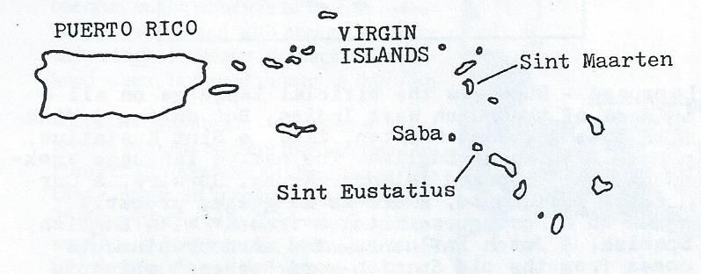
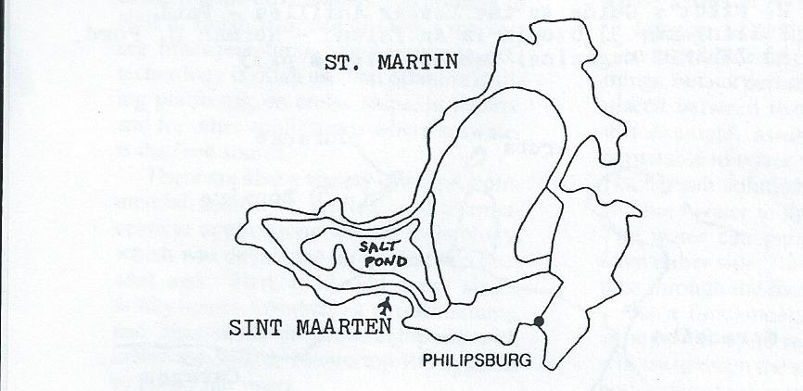
Sint Maarten is the Dutch, southern half of an island, known as St. Martin on the French side, which is divided between Holland & France. Sint Maarten has the largest population of the 3 Dutch Windward Islands, & unlike Saba & Statia, it offers the casinos & nightlife that most vacationers like to find on a tourist island. Travel is unrestricted between the Dutch & French sides of the island, & there are no customs or border formalities. Travel by air to & from Saba & Statia, & usually travel by boat as well, is done via Sint Maarten, whose international airport affords connections with the outside world.
Saba is a 5 square mile dome of rock, an extinct volcano that rise straight out of the sea, reaching 300 feet. Its shoreline is all steep cliffs with no beaches, & no real harbor, although there’s a place called Ladder Bay where boats land. There are 2 villages on Saba, Bottom, at an elevation of 900 feet, lies in the bottom of the valley that was once the volcano’s crater, & Windwardside, higher up on the rim of the crater at 1900 feet. Despite there being almost no level land on Saba, they managed to build an airport, though one with such a short runway that landing on it is almost like landing on an aircraft carrier. A local flight from Sint Maarten flies in & out of Saba each day. About 1000 people live on Saba, some 60% of whom are white, & there are more women than men, since many of the men are away working on ships or on other islands, because there isn’t enough employment on Saba itself.

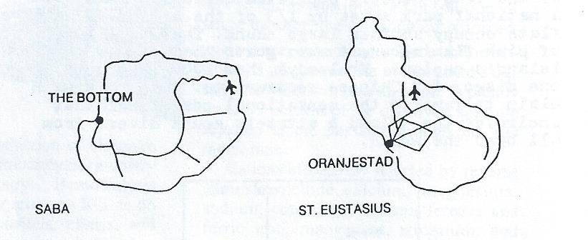

Sint Eustatius (Statia) is a quiet & forgotten backwater whose glory days lie in its past. Back in the time of the American Revolution, Statia’s Oranjestad harbor was jammed with tall ships. But the British burned Oranjestad to the ground in 1780 & Statia has never recovered. Its population, which was once 20,000, has declined to about 1000 today. The island’s 8 square miles consist of 2 volcanic mountains with a valley in between where most of the people live. Tourists on day-trips to Statia climb mountains to see wonderful views of nearby islands, shop in the few stores that make up Oranjestad’s district, explore abandoned buildings & ruins, & snorkel off the island’s 3 black sand beaches. But only the most ardent seekers of solitude are tempted to stay longer. However, several North Americans have purchased land & have started pioneer-type homesteads. There are no import duties or land taxes, & you can bring in just about anything without restrictions. Only a few people of Dutch descent remain on Statia. Most of today’s population is black & English-speaking. To reach the outside world, there is a daily flight from Statia’s local airport to & from nearby Sint Maarten. With its drastic decline in population, there is probably plenty of property available on Statia at much lower prices than on more popular islands. Anyone interested in tropical homesteading should seriously consider this island.

OCEAN FREEDOM NOTES, NUMBER 12
July 1990

DUTCH WEST INDIES – Leeward (ABC) Islands
The Dutch Leewards, or ABC Islands, are not like the usual idea of a Caribbean Island. They’re raised coral islands with no high volcanic peaks, & with dry, cactus-covered, open terrain, rather than jungle. Their culture is a polyglot mixture of Dutch, Indian, Spanish, & much else thrown into their cosmopolitan stew. They’re popular tourist islands, easy to reach with direct flights form NYC & Miami.
Bonaire is a 40 mile long boomerang of sand & coral & bright sunshine. With only a few 1000 people occupying its 112 square miles, Bonaire is one of the least densely populated Caribbean islands. A national park makes up 1/3 of the island, & salt flats occupy another large chunk. There are 1000s of pink flamingoes, & more goats than cars. The island’s capital, Kralendijk, has 1000 residents, one disco, & 2 Chinese restaurants. Bonaire’s main claim to fame is the sensational coral reef that encircles the island & attracts scuba divers from all over the world.

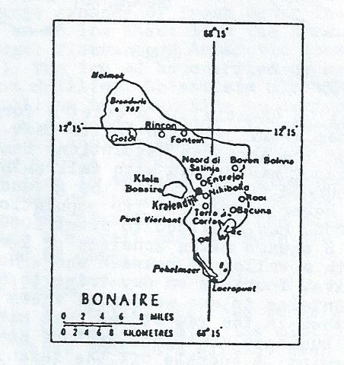

Aruba’s chief attraction is the beach, mile upon mile of the whitest sand in the Caribbean. Swimming there is clothing-optional in the European fashion. Aruba is the smallest but liveliest of the Dutch Leewards, with nightclubs that swing until dawn, gambling casinos, & plenty of restaurants. Strong winds batter the north coast, & inland you’ll find a desert landscape, with interesting cacti, & wind-sculpted trees & rocks.

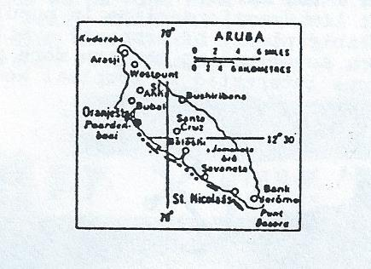

Curacao is the largest & most populated Dutch West Indies. Its capital city, Willemstad, is a unique blend of Dutch gingerbread houses & Caribbean ambience. It’s a clean city, with reasonable prices, a variety of restaurants, & whole streets dedicated to tax-free shopping.

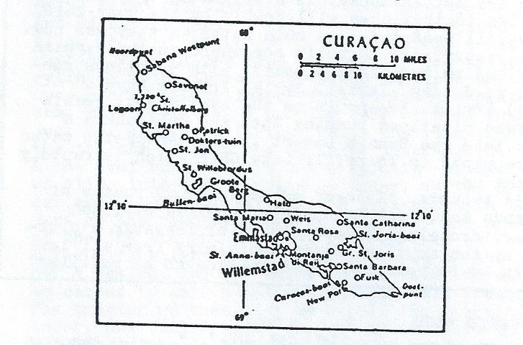

Language – Dutch is the official language on all 6 islands of the Dutch West Indies. But on the 3 Windward islands, Sint Maarten, Saba, & Sint Eustatius, people also speak English. The native language spoken on the 3 Leeward islands, Aruba, Bonaire, & Curacao is Papiamento, a creole language, probably based on a Portuguese “lingua franca” with English, Spanish, & Dutch influence The word “Papiamento” comes from the old Spanish word “papear” which is still used in Puerto Rico and means “talking.” But, since the ABC islands’ economies depend heavily on tourism, mainly from English-speaking N. America, a person could probably manage well enough speaking only English.

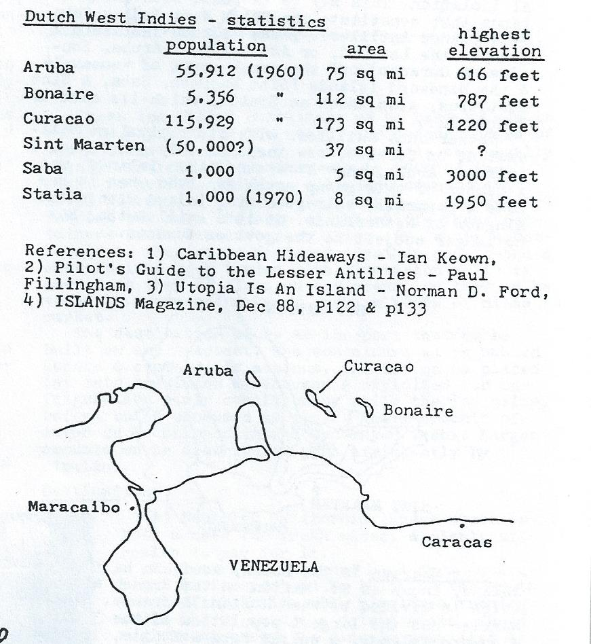

CONTINUE READING BELOW
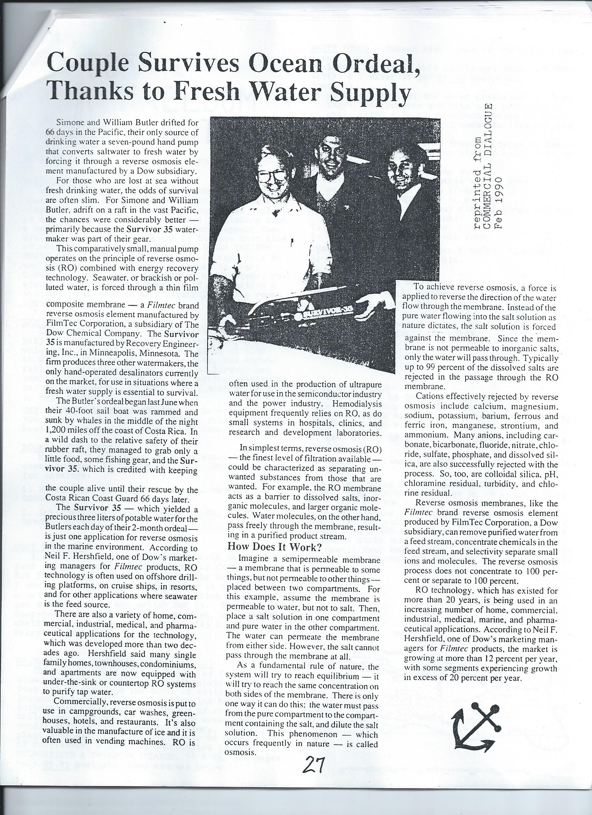
This digitized publication is covered by a BipCot NoGovernment License. This permits re-use and modification to anyone except for governments and the bludgies thereof.

If you enjoyed this publication and appreciate the work put in to digitize it, please consider financially supporting The Vonu Podcast. Make a one-time donation through PayPal, make a monthly contribution through Patreon, or, more in the spirit of vonu, shoot us some Bitcoin or Ethereum. Click the images or use the addresses below. Thanks in advance.
BTC Address: 13kpfpy1DtJ4rnrvMocfvwhFhttzLZe9Pw
ETH Address: 0x019793a6a11b46882b66cc593fe251d249560ad3

